

User’s Manual on
VISUAL RATING (VR) METHOD FOR POTENTIAL SEISMIC VULNERABILITY ASSESSMENT
of Existing Reinforced Concrete Buildings in Bangladesh

The University of Tokyo, Japan Housing and Building Research Institute, Bangladesh

User's Manual on
Visual Rating (VR) Method for Potential Seismic Vulnerability Assessment of Existing Reinforced Concrete Buildings in Bangladesh

Prepared by SATREPS-TSUIB Project
A Japan-Bangladesh Joint Research Project

The University of Tokyo, Japan and
Housing and Building Research Institute, Bangladesh

The contents of this book are related to User’s Manual on Visual Rating (VR) Method for Potential Seismic Vulnerability Assessment of Existing Reinforced Concrete Buildings in Bangladesh which has been described hereinafter in brief practical form as guidelines. As such no chapter, article, clause or sub-clause therefore, be referred to as VALID DOCUMENTS in the event of any arbitration, litigation, dispute, claim case, whatsoever secured, made, or claimed by any person as the case may be under any circumstances.

FOREWORD

Developing countries that are located in the earthquake-prone areas, such as Bangladesh, do not have experience of any recent major earthquake. Although there have been no recent earthquake disasters, experts are now highly concerned due to the repeated occurrence of this catastrophic event in surrounding countries. Therefore, there is an urgent need for seismic screening of the existing RC buildings for evaluation of seismic capacity and subsequently retrofitting and/or strengthening.
At present, Bangladesh has been applying the PWD seismic evaluation manual (CNCRP 2015, BSPP 2021), for detailed seismic evaluation of existing RC buildings, which is adapted from the Japanese seismic evaluation standard (JBDPA, 2001). However, detailed evaluation oflarge buildings stock is quite challenging, especially in developing countries, due to the lack of professional experts and budget constraints. In this regard, identification of vulnerable buildings by rapid screening method and prioritization of existing RC buildings for detailed evaluation is a way to evaluate a large building stock.
This manual presents the development and application procedure of the rapid screening method, namely, the Visual Rating (VR) method, for prioritization of existing RC buildings for detailed seismic evaluation. The VR method is based on visual inspection of an existing building within 0.3~1.0 hr. and approximate seismic capacity using a few fundamental parameters. This manual discusses judgment criteria for setting a priority of detailed evaluation based on VR method score.
This manual presents the starting stage of the proposed VR method. To upgrade the applicability and effectiveness of the proposed VR method, further research on local material properties and local seismicity is necessary. It has been suggested to read the manual thoroughly and apply the method with engineering judgment. We expect feedback from all professional and practising engineers for future upgradation.
We deeply acknowledge all members of Working Group (WG) 2 in the SATREPS-TSUIB project, for their valuable assistance, support, and cooperation. We also thank the PWD engineers from WG2 for their valuable support in the application to existing RC buildings. Finally, we are thankful to the Japan Science and Technology Agency (JST) and Japan International Cooperation Agency (JICA) for their valuable support and cooperation in all aspects of the SATREPS-TSUIB project.

Dr. Yoshiaki Nakano, Professor, The University of Tokyo, Japan
Engr. Md Ashraful Alam, Director General, HBRI, Bangladesh

PREFACE

In developing countries, such as Bangladesh, an enormous stock of vulnerable buildings is to be considered for detailed seismic evaluation, which requires a rigorous analysis with much expertise, cost, and time. In addition, detailed seismic evaluations are very challenging for a large stock of existing RC buildings due to several reasons, including requirements for detailed architectural and structural drawings along with other necessary information that is not available in most of the existing RC buildings. In this regard, identification of the most vulnerable buildings through rapid visual screening, and prioritization of those buildings to conduct detailed evaluation are the effective ways to reduce the aforementioned limitations. Therefore, it is very essential to develop a rapid seismic evaluation method considering the aforementioned parameters influencing the seismic capacity of the existing RC buildings.
This manual focuses on the development of a rapid visual screening method, herein mentioned as Visual Rating (VR) method, for identifying the most vulnerable RC buildings and proposes judgment criteria for prioritization of existing RC buildings for detailed evaluation. The proposed VR method considers the cross-sectional area and shear strength of vertical elements such as RC column, masonry infill wall, and RC wall as well as other building attributes such as structural configuration, deterioration, and age of the building. The presented method estimates the seismic capacity of existing RC buildings in terms of Visual Rating index (I vR) and the lower value of I vR corresponds to the most vulnerable building. Hence these buildings are high priority of detailed seismic evaluation.
Since the main intention of the VR method is to set priority for detailed seismic evaluation, judgment criteria have been proposed for IvR using the obtained correlation between IvR and detailed seismic evaluation results of investigated buildings. Based on the proposed judgment criteria, the buildings with IvR score less than 0.10 are considered as the most vulnerable buildings, and thus detailed seismic evaluation of those is highly recommended. Furthermore, the proposed method can be used in other developing countries by reconsidering material strength properties and local seismicity in the intended region.
The manual will be improved through application in the existing RC buildings. This manual helps to set the strategy for earthquake disaster risk mitigation and to take the decision of retrofitting by having an approximate estimation for the vulnerable buildings.

Dr. Md Shafiul Islam
Senior Research Engineer
Housing and Building Research Institute, Bangladesh

11

ACKNOWLEDGEMENT

Authors:
Lead Author
Dr. Md. Shafiul Islam, Housing and Building Research Institute, Bangladesh Associates Authors
Dr. Masaki Maeda, Tohoku University, Japan
Dr. Matsutaro Seki, Building Research Institute, Japan
Engr. Md. Rafiqul Islam, Public Works Department, Bangladesh Engr. Md. Jahidul Islam Khan, Public Works Department, Bangladesh Engr. Humaira Binte Hasan, Public Works Department, Bangladesh Engr. Md. lftekharul Islam, Public Works Department, Bangladesh Dr. Hamood AlWashali, Tohoku University, Japan
Dr. Debasish Sen, Ahsanullah University of Science and Technology, Bangladesh Engr. Md. Raquibul Hassan, Public Works Department, Bangladesh

Reviewers
Dr. Yoshiaki Nakano, The University of Tokyo, Japan
Engr. Md. Abdul Malek Sikder, Housing and Building Research Institute, Bangladesh

lll

Table of Contents
FOREWORD i
PREFACE ii
ACKNOWLEDGEMENT iii
CHAPTER 1: Introduction 1
  - General Principle 1
  - Scope of Applications 2
  - Definitions 3
  - Notations 4
CHAPTER 2: Visual Rating index (lvR) 5
  - General 5
  - Visual Rating Index (lvR) 5
  - Basic Visual Rating index (/vRB) 6
  - Basic Assumptions for Visual Rating Method 15
    - Basic assumptions for average shear stress 15
    - Basic assumptions for buildings properties 17
    - Basic Assumptions for Modification Factors 19
      - Modification factor for vertical irregularity (Fw) 19
      - Modification factor for horizontal irregularity (FIH) 19
      - Modification factor for deterioration of concrete (Fo) 27
      - Modification factor for year of construction (Fy) 27
CHAPTER 3: Application of Visual Rating Method 31
  - General 31
  - Data Collection Survey Datasheet 31
  - Parameters ofVR Survey Data Sheet. 33
    - Number of Stories (n) 33
    - Average column size ( bc) 33
    - Average Span Length (ls) 35
    - Masonry Infill Ratio (RinJ) 37
V

    - Concrete Wall Ratio (Rcw) 39
    - Modification Factor. 40
      - Vertical Irregularity Factor (Fw) 40
      - Horizontal Irregularity Factor (FIH) 40
      - Deterioration Factor (FD) 40
      - Building's year of construction Factor (Fy) 40
    - Sketch of Floor Plan 41
  - Inspection Procedure 41
  - Guidelines for Filling up the Survey Data Sheet 42
  - Calculation of Visual Rating Index 52
CHAPTER 4: Judgment criteria of Visual Rating index for priority setting 53
  - General 53
  - Judgement criteria of Visual Rating method 53
Reference 57
Appendix Al
Example Building-01 Al
Example Building-02 A4
Joint Coordination Comrnittee A7
Working Group2 (WG2) mernbers A8

Vl





CHAPTER 1: Introduction

  - General Principle

The Visual Rating (VR) method has been developed for rapid screening of RC framed buildings with or without infill brick masonry walls or RC walls for potential seismic hazards. This manual has been prepared to:
understand the background of development of Visual Rating (VR) method demonstrate the application procedure of the VR method among audiences ranging from professional engineers and practitioners to appropriately trained nonprofessionals with general familiarity or background in building design or construction.

This manual mainly contains the following:
    - Survey datasheet in which each item has been explained in detail.
    - Scoring method of RC framed buildings with an objective to prepare a priority list for potential vulnerability analysis.

This manual has been developed to facilitate the execution of rapid screening of masonry infilled RC framed buildings. VR method is a screening method and it must not be used to declare the final structural vulnerability (or risk). For a final decision on the vulnerability (or risk) of a building, a detailed structural assessment shall be done. This VR method provides a very rough idea about the seismic capacity and the judgment for detailed evaluation shall be proposed.

The manual contains four chapters. The first chapter includes the scope of this manual. In the second chapter, the background of this VR method has been briefly discussed. The third chapter provides guidance on completing the survey datasheet and interpretations of survey results. Finally, the fourth chapter covers the judgment criteria of the VR index for priority setting of detailed seismic evaluation. There are several examples of field survey data sheets and VR Index calculations attached in the supplement part.

1

  - Scope of Applications

The scope of this manual shall be limited to the following conditions:
    - The provisions of this manual shall be applied to RC framed buildings with or without infill brick masonry walls or RC walls.
    - Buildings of 6 stories or less are covered in this manual. Buildings higher than 6 stories shall be considered with special attention.
    - Building frames with concrete strength not less than 9.0 N/mm² are covered in this manual.
    - This manual shall not be applied to severely deteriorated buildings due to fire incidents, time deterioration, significant settlement, and structural cracks, etc.

The Scope of the application has been developed from "The Japanese Technical Manual for Seismic Evaluation and Seismic Retrofit of Existing Reinforced Concrete Buildings, 2001" Published by The Japan Building Disaster Prevention Association (JBDPA), and its adapted version namely, "PWD Manual for Seismic Evaluation of Existing Reinforced Concrete Buildings" for Bangladesh prepared under the CNCRP project funded by The Government of Bangladesh (GoB) and Japan International Co-operation Agency (JICA). The manual has been published by Public Works Department in 2015.

Most importantly, it shall be noted that Visual Rating (VR)method can only be used as a tool to identify the building which requires more attention for further seismic vulnerability assessment.
VR survey can be conducted by the following professionals and non-professionals with basic training on VR method:
1. Project Manager with a Civil Engineering background with in-depth knowledge on the Visual Rating method.
11. Civil and Structural Engineer.
111. Appropriately Trained Supervisors (Diploma in Civil Engineering). 1v. Appropriately Trained Surveyors (Diploma in Civil Engineering).

2

Among the above listed people, the Project Manager will prepare a number of working teams considering the volume of buildings, available funds and time limit, etc. The Project Manager is also responsible to select suitable persons for YR Index calculation level, supervision level, and survey level. Only Professionals in Civil and Structural Engineering disciplines can calculate YR Index on their own. Others will supervise and conduct the survey only. The estimated survey time for a 6 storied building with an area ranging from 300 to 400 square meters per floor may require around 30 to 45 minutes for a survey team consisting of two surveyors.

  - Definitions

Column area ratio: The ratio between the total cross-sectional area of columns in a story and the total floor area of a whole structure.
Infill wall area ratio: The ratio between the total cross-sectional area of masonry infills in a story and the total floor area of a whole structure.
Irregularity index: An index modifying the Visual Rating Index (lvR) for horizontal and vertical irregularity.
RC wall area ratio: The ratio between the total cross-sectional area of reinforced concrete (RC) walls in a story and the total floor area of a whole structure.
Simplified column area ratio: A simplified way to estimate column area ratio in Visual Rating method.
Simplified infill wall area ratio: A simplified way to estimate infill wall area ratio in Visual Rating method.
Simplified RC wall area ratio: A simplified way to estimate RC wall area ratio in Visual Rating method.
Time index: An index modifying the visual rating index for deterioration and buildings age.
Total floor area: Total floor area of a whole structure.
Visual Rating index: An index representing the score of Visual Rating method.
Visual Rating method: A simplified procedure to estimate the seismic capacity of an existing building.

3

  - Notations

IvR  n | Visual Rating index  Number of stories
Tc | Average shear strength of column
Tin/ | Average shear strength of masonry infill
Tew | Average shear strength of concrete wall
Ac | Cross-sectional area of all columns in a story
Ainf | Cross-sectional area of all masonry infills in a story
Acw | Cross-sectional area of all concrete walls in a story
Ai | Floor area of a story of a structure
w | Unit weight per floor area of a building
le | Simplified column area ratio
linf | Simplified masonry infill area ratio
few | Simplified concrete wall area ratio
be | Average size of columns
ls | Average span length
Rinf | Masonry infill ratio
Rew | Concrete wall ratio
linf | Masonry infill thickness
tcw | Concrete wall thickness
FJV | Vertical irregularity factor
Fm | Horizontal irregularity factor
FD | Deterioration factor
Fy | Building's year of construction factor
ho | Clear height of column
D | Width of column
nc | Total number of RC columns
L | Length of building
B | Width of building

4


CHAPTER 2: Visual Rating index (lvR)

  - General

In this chapter, the theoretical background, and development procedure of the Visual Rating method has been described. In the beginning, several literatures related to the theoretical background of the proposed VR method have been discussed. Afterwards, the development and assumptions considered for the proposed Visual Rating method have been discussed in detail.

  - Visual Rating Index (JvR)

Visual Rating index of an existing building, IvR, is calculated by the following Eq. (2.1):
(2.1)
were,
lvRB=Basic Visual Rating index (see section 2.3)
Fw = Modification factor for vertical irregularity (see section, 2.4.3.1)
FII-F Modification factor for horizontal irregularity (see section, 2.4.3.2) FD= Modification factor for deterioration of concrete (see section, 2.4.3.3) Fy= Modification factor for year of construction (see section, 2.4.3.4)

5

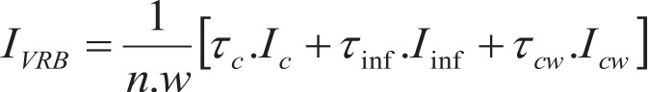
  - Basic Visual Rating index (lvRB)

The basic Visual Rating index (lvRs) is calculated considering column area ratio, RC wall area ratio, masonry wall area ratio and their average shear strength (see commentary 1). Since the proposed method is based on visual inspection, this Visual Rating method approximately estimates column area ratio, RC wall area ratio and masonry infill area ratio by more simplified way thorough visual investigations. Therefore, the simplified seismic capacity index of existing buildings is expressed by following Eq. (2.2).

(2.2)

where,

Simplified column area ratio, Jc = ..1_;::; b: (see commentary 1-2.1)
A1 ls
Simplified masonry infill wall area ratio, 1 r = Ainr ;::;tinr .R·r (see commentary 1-2.2)
in A l in
f s

Simplified RC wall area ratio, 1 = Acw ""tcw.R (see commentary 1-2.3)
l
CWA cw
f s

n= number of stories of a building (see section, 3.3.1)

be=Average size of columns (see section, 3.3.2) ls =Average span length (see section, 3.3.3) Ri,v=Masonry infill ratio (see section, 3.3.4) Rew= Concrete wall ratio (see section, 3.3.5)
re= Average shear strength of column (see section, 2.4.1)

Ti,!F Average shear strength of masonry infill (see section, 2.4.1) Tew=Average shear strength of concrete wall (see section. 2.4.1) w=Average unit weight per floor area (see section. 2.4.2)
lin.F Thickness of masonry infill (see section. 2.4.2)

tcw= Thickness of concrete (see section. 2.4.2)

6

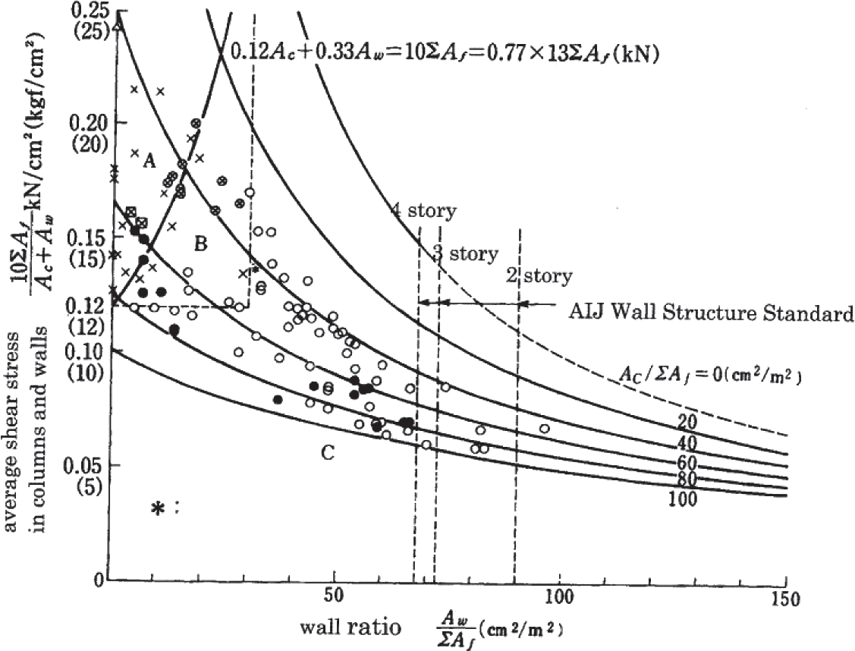
[Commentary-1]
(1-1) Theoretical Background of Visual Rating method and Visual Rating index
The main concept of the Visual Rating method originates from Shiga Map (Shiga et al.1968), which has been proposed after investigating the damaged buildings in the 1968 Tokachi-Oki earthquake, Japan as shown in Figure 2.1. The Shiga map considers two simple parameters: the ratio of the average shear stress of columns and RC walls based on their cross-section area, and the RC wall area ratio (A ratio of the total cross-sectional areas of RC walls in the first story to the total floor area).

Damage to buildings in and near Hachinohe city due to the 1968 Tokachi-oki Earthquake

Failure due to torsional displacement

Figure: 2.1 Shiga map (Shiga et al. 1968)

Afterward, this Shiga map showed good agreement with the damage status of RC buildings in the 1978 Miyagi earthquake (Shibata A., 2003). However, this method is applicable only for buildings with RC shear walls, which does not consider the effects of masonry infill. Later on, Hassan and Sozen (1997) presented a simplified method with fundamental parameters such as column and wall area ratio to rank RC framed buildings according to their vulnerability against seismic damages. This method has been validated by the investigation of damaged buildings in the 1992 Erzincan Earthquake, Turkey as shown in Figure 2.2.

7

Figure: 2.2 Proposed evaluation methods by Hasan and Sozen (1997)

From the above discussion, it has been concluded that the simple two parameters such as column area ratio and infill wall area ratio have great influences on seismic capacity. Furthermore, Islam M.S. (2019) studied several earthquakes damaged databases such as the 2015 Nepal Earthquake, the 2016 Ecuador Earthquake, the 2016 Taiwan Earthquake, and the 1992 Turkey earthquake. As shown in Figure 2.3, it has been observed that column area ratio and masonry infill area ratio showed good agreement with the damage state of existing buildings, based on past earthquake databases. Thus, the column area ratio and wall area ratio are the key parameter for the estimation of seismic capacity.
- None 11 Light
- Moderate )I( Severe ■ Severe ■Moderate

�
.0...........
e<:l
1--,
e<:l
1.5
•
•

,-.., 100%
'-'
�
.0...........
e<:l
75%
- Light ■None
■
■

<l)
1
�
= • •
s
<one,.q
�
<l)
50%
/;)f)
se<:l
■
25%

o;::l

u
0.5

)I(

<onee
•
e<:l
0 0%

)I(\
Zone C
0
A B C
Zone

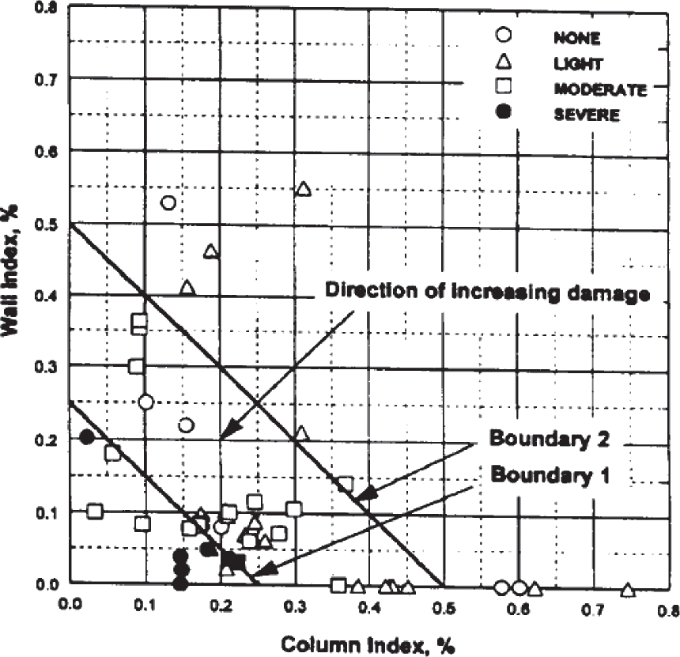





0 1 2 3 Zone A= Light and Safe
Masonry infill wall area ratio, % Zone B= Moderate Zone C=Severe
Figure: 2.3 Column area ratio and infill wall area ratio with damage ratio (Islam, MS, 2019) 8

(1-2) Development of the basic Visual Rating index
Based on the Shiga map concept, the Japanese seismic evaluation method (JBDPA) (JBDPA 2001) proposes a practical way of estimating the seismic capacity of existing RC buildings. The JBDPA standard (JBDPA 2001) considers three levels of seismic evaluation procedures to estimate seismic capacity in terms of seismic index (Is). According to the JBDPA standard (JBDPA 2001), the seismic index (Is) is estimated by following Eq. (C2.1).
Seismic index (Is)= Eo x Sd x T (C2.1)
where Eo= the basic seismic index= C x F. C is the strength index which is expressed as the base shear coefficient of RC building. F is the ductility index based on the deformation of the existing RC building. Sd is the irregularity index considering both horizontal and vertical irregularity. T is the time index considering the deterioration of concrete, corrosion of reinforcing steel, and buildings year of construction.
In the first level evaluation, strength index (C) can be estimated by lateral strength (V) normalizing with the total building's weight (W) as shown in Eq. (C2.2). Here, lateral strength
(V) is simply calculated by the cross-sectional area of vertical elements and their average shear strength. However, the ductility index (F) is considered 1.0 assuming the building is brittle.

Strength index, C = I:_
w
(C2.2)

The second level evaluation procedure considers detailed calculation for estimation of strength index (C) and ductility index (F) based on lateral force-deformation capacity and failure mechanism of each vertical member (JBDPA 2001). However, detailed architectural and structural drawings along with reinforcement details are required for both evaluation procedures.
Based on the first level evaluation procedure of the JBDPA standard (JBDPA 2001), the strength index (C) of masonry infilled RC building is calculated by Eq. (C2.3) proposed in the previous study (Islam, MS 2018, Maeda M, 2018).

C = _!_[,c·_1._ + 'inf• /4ir + Tew·Acw]
w n.A1 n.A1 n.A1
(C2.3)

where, Tc, Tinf, and Tew are the average shear strength of RC column, masonry infill, and reinforce concrete wall; Ac, Ainf, and Acw are the cross-sectional areas of RC column, masonry infill, and reinforced concrete wall. n is the number of stories, A1is the floor area, and w is the unit weight per floor area of an RC building. In the Eq. (C2.3), Acln.A1, Ain/n.A1, and Acwln.A1is expressed as column area ratio, masonry infill area ratio, and concrete wall area ratio, respectively.

9

The basic seismic index, Eo, can be calculated by considering C index from Eq. (C2.4) and
F index is 1 (one) as follows:

(C2.4)

Hence, the seismic index (Is) of first-level evaluation as shown in Eq. (C2.1), considering masonry infilled RC buildings, can be estimated by following Eq. (C2.5).
l

IS =- I [ TcA.-c-+TinfA•in-f-+TcwAc·w--'S
w n.A1 n.A1 n.A1
DT'
(C2.5)

Although the first level evaluation method is very simple and easy to apply, it is quite challenging to apply to large numbers of existing buildings because it requires architectural drawings. If architectural drawings are not available, as-built drawing preparation is necessary, which takes much time and effort for the seismic evaluation procedure. For this instance, the VR method proposes a simplified way of estimation of column area ratio (Acln.A1) masonry wall area ratio (Ain/n.A1), and concrete wall area ratio (Acwln.A1) by visual inspection instead of measuring the cross-sectional area of all RC column, infill wall, concrete wall, and total floor area. A simplified way considers visual inspection, and collection of several parameters which provide an approximate estimation of column area ratio, masonry infill area ratio, and concrete wall area ratio. This method proposes a score, hereafter reported as Visual Rating index (JvR), which is approximated seismic capacity of existing buildings. The calculation procedure of Visual Rating index (JvR) is described in the following section. The Visual Rating index (JvR) indicates the seismic capacity of existing buildings which is expressed by Eq. (C2.6).

IVR =- I [ TcA.c-+TinAfin'-f +TcAwc·w-l'SDT'
n� � � �
(C2.6)

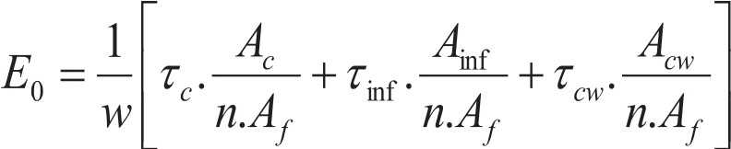
where, AclA1, Air/Ai, AcwlA1 can be expressed as simplified column area ratio, simplified masonry infill area ratio, and simplified concrete wall area ratio, respectively. It should be noted that these simplified column area ratios, masonry infill area ratios, and concrete wall area ratios are calculated for a single floor of a building. The following sections describe the simplification procedure in detail.
(1-2.1) Simplified column area ratio (le)

Simplified column area ratio (le) is defined as approximate estimation of column area ratio of

an existing buildings using simple way thorough visual survey. As previously mentioned, column area ratio consists of cross-sectional areas of all column and floor area. However, it is not easy to measure the cross-sectional areas of all columns and floor area within short time by visual investigation. Thus simplification of column area and floor are alternative approach for easy understanding of column area ratio. Sometimes, columns are surrounded by masonry infill which is common practice in Bangladesh. In that case, rigorous inspection is needed for preparation of as-built drawing which takes much time. Therefore, this method considers to investigate of these columns which are easy visible during building survey and inspection.
In this method, the cross-sectional area of column is simplified using average column size (be), The average column size (be) represents all column dimension of an investigated buildings. This proposed method proceeds the inspectors to enter inside the building and investigate columns by visual inspection of a building to be surveyed. Afterward, the average column size (be) has been chosen depending of inspector's engineering judgement. A typical floor plan has been shown in Figure 2.4. Inspectors, after entering inside the house, can easily investigate column size of interior column rather than exterior columns. In this regards, it has been suggested that surveyor investigate two or three interior column and make a decision of average columns size.

�w

!w
(7 7 7 7 7 7 1 D
Is w
w

w

D D

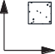
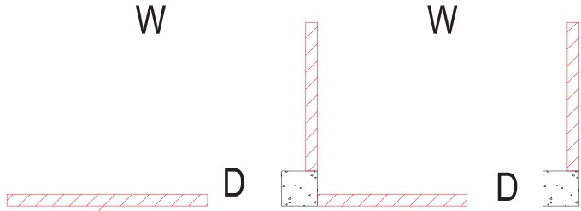
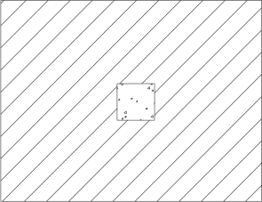

w
y !w w w w w
X W=Window, D=Door
Figure 2.4 Schematic floor plan of a building with average span length

On the other hand, it is also difficult to measure floor area by visual inspection within short time. Because, it requires as-built drawing preparation if architectural drawings are not available which takes longer time for building survey. However, this method considers average span length (ls) of building in both directions to overcome the limitation. The square of average

11

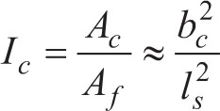
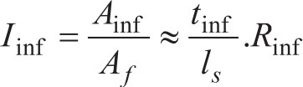
span length (ls) is a simplest way to approximately estimate the floor area of a buildings in a short time. Generally, the span length is not equal in each direction and also number of span are not the same. In this context, the investigator should check and measure one or two spans in both direction (longitudinal and transverses direction) of a building. Afterward, the appropriate value for average span length is chosen based on engineering judgement. Figure 2.4 shows an example of inspection procedure of average span length (ls) of a surveyed building. Hence, simplified column area ratio is estimated by average column size (be) and average span length (ls) using Eq. (C2.7) as follows:
(C2.7)

(1-2.2) Simplified masonry infill area ratio (h,j)

Simplified masonry infill area ratio is an approximate estimation of masonry infill area ratio of a building. The simplified masonry infill area is based on using simplified masonry infill area and floor area. However, floor area can be approximated using average span length (ls) which is already explained in previous section. So, this section explains about the simplification procedure of masonry infill area based using simple parameter depending on visual inspection.

Generally, solid masonry infill i.e. without opening and with opening due to door, window and high window are common in RC buildings. Sometime, partial masonry infill are also found in existing buildings. It is difficult to measure length and width of each masonry infill either solid or with opening by visual inspection within short time. However, it is easy to count the number of masonry infill panel in each direction by visual inspection instead of measuring dimension of each masonry infill. Thus, masonry infill area can be easily estimated using number of infill panels, average span length (ls) and thickness of masonry infill (tin/) in each direction. Since the proposed method is based on visual inspection with limited time, it is should be noted that the partial infill or infill with opening due to door and window is not considered in this method. Therefore, only solid masonry infill is considered for estimation of masonry wall area to be in conservative. Hence, the masonry infill area ratio has been simplified by using masonry infill ratio (RinJ), thickness of masonry infill (tin/) and average span length (ls) as shown in Eq. (C2.8).
(C2.8)

12

where, Rinf is the masonry infill ratio which indicates the quantity of masonry infill expressed as the ratio of the total number of solid masonry panel in a direction to the total number of spans for that direction. As previously mentioned, masonry infill with opening due to door and window are not considered in the proposed method. Figure 2.5 shows example of different types of opening. It should be noted that the solid infill outside the RC frame will not be considered. Therefore, Masonry infill area ratio (RinJ) is simplified as expressed by Eq. (2.9).

R. = Number of masonry panel in a direction mf Total no of span in a direction
(C2.9)

_J L J L J L
. . JI I [ _JI _I [ _IJ_I [

(a) Solid infill (b) Infill with high window (c) Infill with cont. window

_J '-' �
L JI IL_JI
IL_

. I. J_I [ _IJ_I [ J I _I [

(d) Infill with central window (e) Infill with side window (f) Infill with door (central)

_JI
ll JI IL_JI
IL_

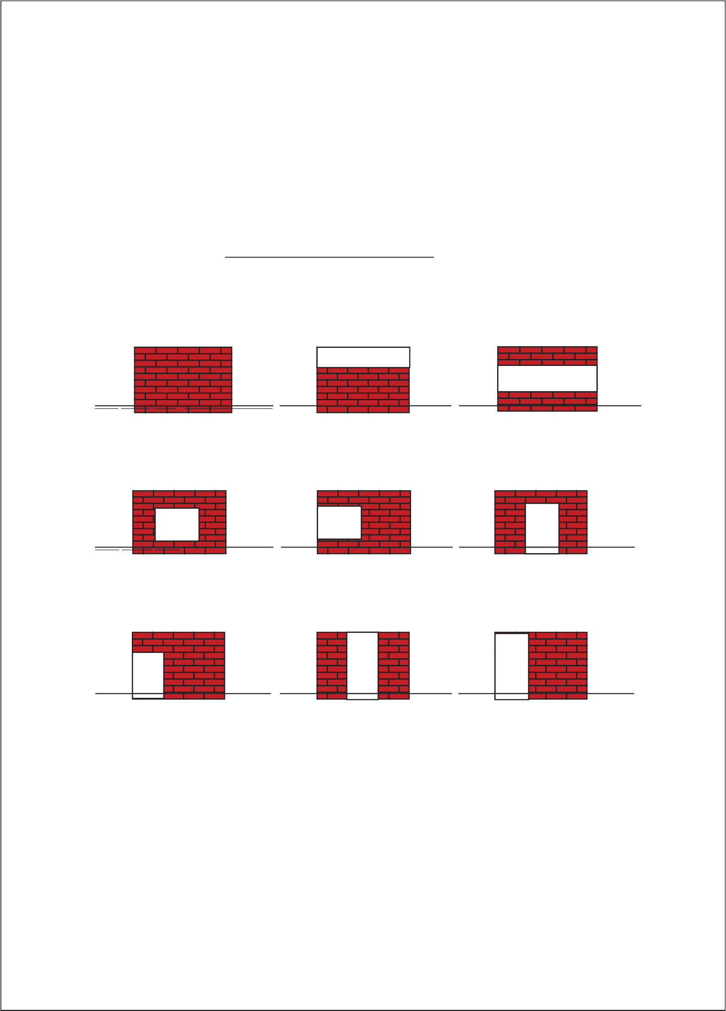
JI I[ JI I [ JI I[
(g) Infill with door (side) (h) wing wall (i) wing wall

Figure 2.5 Masonry infill with different types of opening

Since the proposed method considers visual inspection, it has been suggested that the surveyor will count number solid masonry infill and number of spans are also counted for both directions by visual inspection. Afterward, Masonry infill ratio, Rinf, shall be calculated for both orthogonal directions. Finally, the minimum values of RinJiS considered to be in conservative.

13

A typical floor plan is shown in Figure 2.6 as an example of calculation procedure of simplified masonry infill wall area ratio. As described in previous sections, masonry infill with opening is not considered in this method. Therefore, the number of solid masonry infill panels are 2 in X direction and 3 in Y direction as shown in Figure 2.6. On the other hand, the total number of spans are obtained as 16 and 15 in X and Y direction, respectively. Therefore, Rinf are to be found 2/16 and 3/15 for X-direction and Y-direction respectively. Here, minimum Rinf value 2/16 has been considered for capacity prediction.

w w

w
□ q

w w
X

w
W=Window, D=Door

Figure 2.6 Typical floor plan showing location of masonry infill

(1-2.3) Simplified concrete wall area ratio (lcw)
The concrete wall area ratio has been simplified by using similar way of masonry infill area ratio (Ln1) as discussed in the previous section. Therefore, it is simplified by concrete wall ratio (Rew), thickness of concrete wall (tew) and average span length (ls) as shown Eq. (C2.10).
Jew= Acw,:::, tcw .Rew (C2.1Q)
A1 ls
where, concrete wall ratio (Rew) indicates the quantity of concrete wall expressed as the ratio of the total number of solid concrete wall panel in a direction to the total number of spans for that direction as shown in Eq. (C2.11).

R = Number of concrete wall in a direction cw Total no of span in a direction
(C2.11)

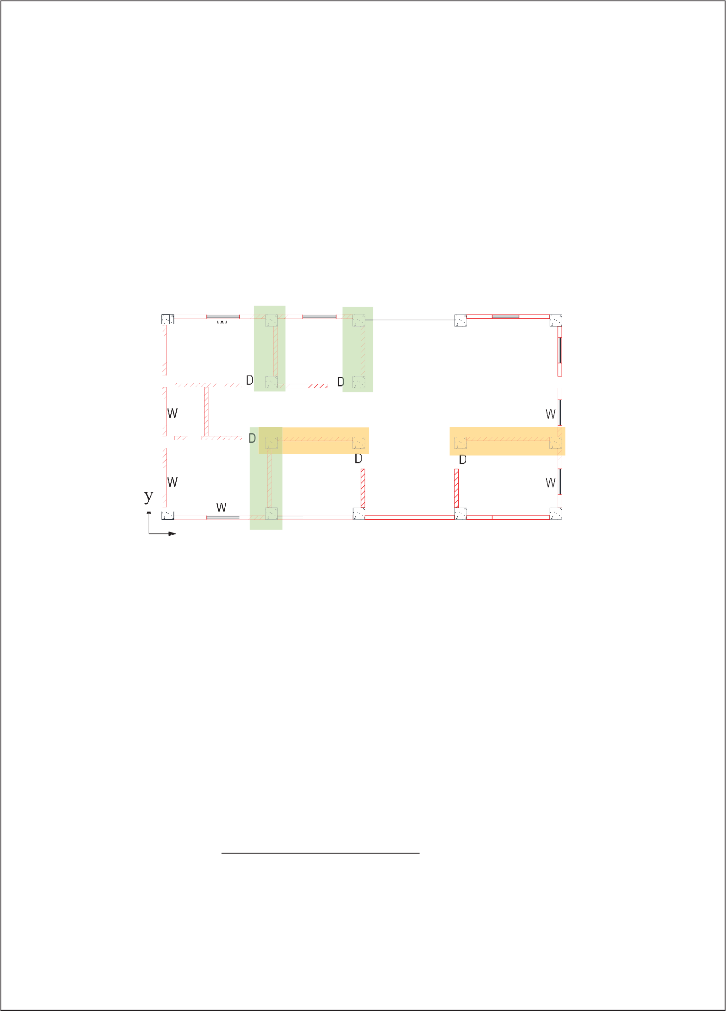
Concrete wall with opening due to door and window are not considered in this method. Rew
shall be calculated for both orthogonal directions and the minimum value is considered.

14

Considering simplified form of column area ratio (le), masonry infill area ratio (hef), and concrete wall area ratio (Jew), the basic Visual Rating Index (lvRs), the Eq. (2.2) can be re-written as follow as Eq. (C2.12):

IVR_B - -
1 [ Tc (2bl) + Tinf· (t-i.nf Rinf ) + Tew· (t-c.w Rcw)]
(C2.12)

n.w ls ls ls

  - Basic Assumptions for Visual Rating Method

The VR method considers basic assumptions for several parameters such as material properties, buildings unit weight, thickness of masonry infill, and structural wall as well as seismic capacity modification factors.
    - Basic assumptions for average shear stress
      - Average shear strength of column (re)
Average shear strength is of 1.0 MPa. (see commentary 2-1)
      - Average shear strength of masonry infill (Tinj)
The average shear strength of masonry infill, Tin/, is considered as 0.2 MPa. (see commentary 2-2)
      - Average shear strength of concrete wall (Tew)
The average shear strength of reinforced concrete wall (rcw) is assumed 1.0 MPa (see commentary 2-3)

[Commentary 2]
(2-1) Average shear strength of column (re)
Many guidelines and researchers consider a single value for the average shear strength of RC column as a conservative approach. In Japan, the Japan Building Disaster Prevention Association (JBDPA 2001) proposed a seismic evaluation standard that considers the average shear strength of column as 1.0 MPa for the first level screening procedure based on shear-span-to-depth ratio, where halD ranged 2 to 6 (ha is the clear height of the column, D is the column width). Figure 2.7 shows a relationship between shear strength of column and ha!D ratio based on analyses of existing buildings located in Dhaka, Bangladesh (Islam MS 2019). It has been observed that the shear strength of the RC column ranges from 0.60 to 1.75. The lower boundary of shear strength provides more conservative results. On the other hand, the

15

upper boundary overestimates the seismic capacity. From the above discussion, this method assumes the average shear strength is 1.0 MPa.

ell�
§
2
0
@
1.5 t- 0

-;:l 0
-� 1 8
0
(.)
0
i
I
4o-< --r-o t-
..i:::: 0-..
bf)'-' 0
� "
� !--> 0.5 t-
[/J
rI-o<
Q)
..i:::: I I I

[/J
0
2 4 6 8 10
hjD

Figure 2.7 Average shear strength for column vs. ho/D ratio for investigated RC buildings in Bangladesh (Islam MS, 2019)

(2-2) Average shear strength of masonry infill (TinJ)
There are several guidelines about considering of shear strength of masonry infill. ASCE seismic guideline (ASCE/SEI 41-06 2007) prescribed 34 psi (0.24 MPa) for good masonry condition. In a developing country such as Nepal, the average lateral strength for a masonry infill wall is assumed of 0.28 MPa based on past experimental studies (Karmacharya, U 2018, Pradhan, 2009). Figure 2.8 shows the maximum shear strength of masonry infill corresponding to the compressive strength of masonry prism (Alwashali, 2018). From the discussion above, a value of shear strength of masonry infill, Tin/, is considered as 0.2 MPa, which is a conservative value for masonry with compressive strength ofless than 10 MPa, as shown in Figure 2.8.
1
◊◊
◊
◊
◊ ◊
◊o ◊
◊◊ ◊ o◊
◊

...i.:.:.:.: ---
�� 0.8
��
: �0.6
ro ·-
Q) !-->
�a � 0.4

o
S �

·- a
0.2

:>< 4-<
0
ro o
� 0 5 10 15 20
Compressive strength of masonry prism (MPa)

Figure 2.8 Average Shear Strength for Masonry Infill with Compressive Strength of Masonry infill (Alwashali, 2018)
16

(2-3) Average shear strength of concrete wall (Tew)
JBDPA standard (2001) proposed the average shear strength of concrete walls without boundary columns is 1.0 MPa based on past damage investigation and experimental data. In this method, the average shear strength of the concrete wall (rcw) has been assumed 1.0 MPa for very preliminary evaluation.
    - Basic assumptions for buildings properties
      - Thickness of masonry infill (t;,,1)
The masonry infill thickness (tinJ) as 125 mm for single layer of infill panel. In case of infill wall thickness of 250 mm, the number of walls should be counted twice of 125 mm thick infill wall.(See commentary 3-1)
      - Thickness of concrete wall (tcw)
The minimum thickness of concrete wall (tcw)is assumed 200 mm. (see commentary 3-2)

      - Average unit weight per floor area (w)
The average unit weight per floor area, w, is set as 1lkN/m². (see commentary 3-3)

[Commentary 3]

(3-1) Thickness of masonry infill (tinJ)
In general, the thickness of masonry infill is about 125 mm which is common practice in masonry infill RC buildings in Bangladesh. Besides, the thickness of masonry infill varies within a range of 125 mm to 250 mm as found in the field survey in Bangladesh (Islam MS 2019). Sometimes for public buildings such as office buildings, the thickness of exterior wall and interior wall is 250 mm and 125 mm. This method assumes the masonry infill thickness (tinJ) as 125 mm for a single layer of infill panel. In the case of the infill wall thickness of 250 mm masonry wall, the number of walls should be counted as twice of 125 mm thick infill wall.
(3-2) Thickness of concrete wall (tcw)
The thickness of a concrete wall ranges from 200 mm to 300 mm as found in existing buildings in Bangladesh (Islam MS 2019). In this method, the minimum thickness has been conservatively assumed 200 mm as the lower boundary.
17

(3-3) Average unit weight per floor area (w)
The unit weight per floor area of existing buildings is found to range from 10 to 12 kN/m² based on a study of existing RC buildings located in Bangladesh (Islam MS 2019). Therefore, in this method, the average unit weight per floor area, w, is set as 1 lkN/m².

18

    - Basic Assumptions for Modification Factors
Modification parameters includes, building's irregularities due to vertical irregularity and horizontal irregularity, deterioration and buildings' age.
      - Modification factor for vertical irregularity (F,v)

Modification factors for vertical irregularity are shown m Table 2.1. (See commentary 4-1)
Table 2.1 Modification factors for vertical irregularity (Fw)

Items | Regular | Nearly Regular | Irregular
Criteria | No opening at | Small openmg at ground | Soft story or open
 | ground floor | floor and setback (See Figure  2.10 a-b) | ground floor (See Figure  2.10 c)
F1v | 1.0 | 0.8 | 0.6

      - Modification factor for horizontal irregularity (FIH)

The modification factors for different horizontal irregularity factors are shown in Table
2.2. For more clarification, the criteria for plan irregularity are shown in Figure 2.12 in commentary 4-2.
Table 2.2 Modification factor for horizontal irregularity (Fm)

Items Regular
Nearly Regular
Irregular

Shape Regular shape L, T or U- L, T or U-

shaped plan.
The projection area, "a" < 10 % of < 30% of (as shown in shaded part)* floor area floor area FIH 1 0.9
shaped plan

> 30% of floor area
0.8

*Projection area indicates shaded part in the Figures 2.12 (a-d)

19

[Commentary 4] Buildings Irregularities
Many seismic evaluation guidelines in different countries such as American Standard (ASCE/SEI 7-10), Japanese seismic evaluation standard (JBDPA), New Zealand standard 2004 (NZS 1170.5), describe the irregularities of buildings into two categories. These are vertical and horizontal irregularities. Moreover, those seismic evaluation guidelines propose different approaches to consider these influencing parameters during seismic capacity evaluation.
Past earthquake damage investigation helps to quantify the irregularities of existing RC buildings. However, the existing rapid visual screening method proposed several factors for seismic influencing parameters based on a study of past earthquake damage databases, engineering justification, and also individual perceptions.
Japan Building Disaster Prevention Association (JBDPA) (JBDPA 2001) proposed a standard for seismic capacity evaluation that does not cover masonry infilled RC buildings. In this method, JBDPA (JBDPA 2001) manual is extended to be used for the masonry infilled RC structures for modifying the Visual Rating Index, according to the horizontal and vertical irregularity. Therefore, the proposed method assumes modification factors following the Japanese seismic evaluation standard during the estimation of Visual Rating index. The following sections describe seismic capacity reduction factors due to vertical and horizontal irregularities:
(4-1) Vertical irregularity factor (Fw)
It is generally accepted that the vertical irregularity significantly influences the se1sm1c performance of RC buildings more than that of horizontal irregularity. Many researchers reported different types of vertical irregularities such as story stiffness distribution along with the height, the inconsistency between adjacent floors, ground floor parking, soft-story, etc. Usually, opening and soft story due to ground floor parking and commercial usage which are commonly found in most of the RC buildings in developing countries. Many buildings were severely damaged due to these types of irregularities as shown in Figure 2.9 in Nepal Earthquake 2015 (datacenterhub.org).

20

Figure 2.9 Examples of buildings subjected to soft-story collapse during the 2015 Nepal earthquake (datacenterhub.org)

It is necessary to quantify the aforementioned vertical irregularities for taking into account the seismic evaluation procedure. However, it is not easy to investigate all types of vertical irregularities by visual inspection within a very short time. Hence, this method considers full and partial openings on the ground floor, setbacks, etc. which can be visually observed during a building survey and inspection. Therefore, this method classifies the vertical irregularities into three categories for easy understanding such as regular, nearly regular, and irregular as shown in Figure 2.10.

(a) Setbacks (b) Some panels without infill on the ground floor
(c) soft or open story

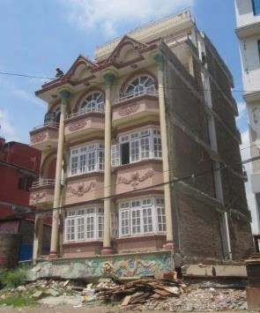
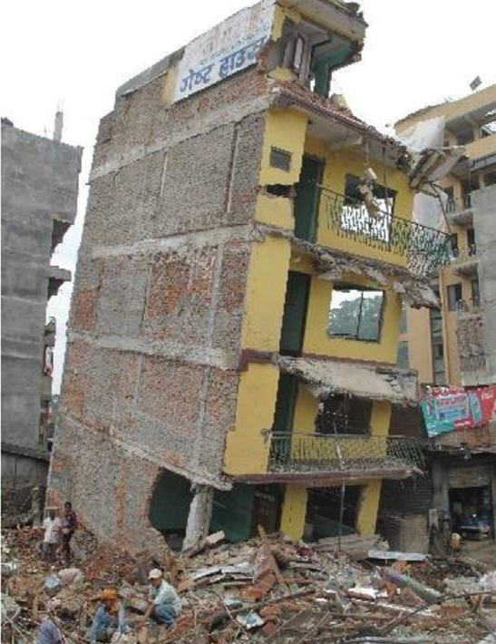
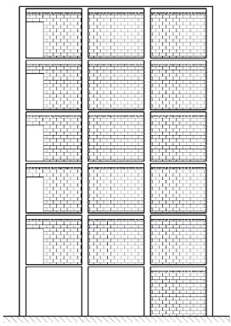
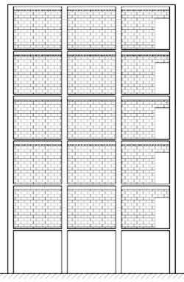
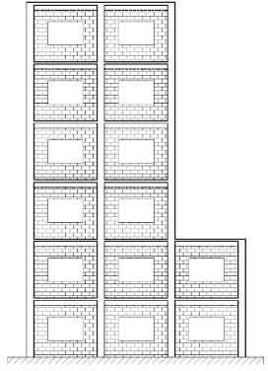
Figure 2.10 Elevation view of some typical RC frames having vertical irregularities.

21

A vertical irregularity factor (Fw) has been imposed in this method to quantify the vertical irregularity of existing buildings. In this context, many researchers and seismic evaluation code proposed values for quantification of these types of irregularity in seismic evaluation procedures (JBDPA 2001; Sucuoglu et al. 2007; Ozcebe et al. 2004, Al-Nimry et al. 2015). This method assumes modification factors which are based on Japanese seismic evaluation procedure.

The reduction factors for different vertical irregularity criteria are shown in Table 2.1 (JBDPA 2001) described as follows:
- Regular: The building has been considered regular if there are no significant vertical irregularities. In this case, the value has been considered as unity.
- Nearly Regular: Partial openings on the ground floor as well as setbacks are sometimes present in existing RC buildings [See Figure 2.l0(a)&(b)] which are also responsible for the reduction of seismic capacity during an earthquake.
- Irregular: Opening on the ground floor due to car parking is very common for mid-rise RC buildings in developing countries [See Figure 2.lO(c)].
Many guidelines and researchers propose values for reduction factors for open ground floor or soft story effect. However, Al-Nimry et al (2015) proposed reduction factors for soft-story structures of 0.85 and 0.75 for mid-rise and low-rise buildings respectively. It indicates about a 15% to 25 % of reduction of actual seismic capacity. Similar observations also have been found by other researchers such as Sucuoglu and Yazgan (2003), Gulkan and Yakut (1994), Magliuloet al. (2002) based on engineering judgment and field observations of actual earthquake damages. It has been concluded that the earthquake response magnifies about 13.5
% to 20% due to soft story compared with regular buildings. Furthermore, JBDPA (2001) proposes a reduction factor for a soft story of about 0.9 and an eccentric soft story of 0.8 for both first-level, and second-level evaluation. As the proposed method is based on visual inspection within a short time, this method assumes vertical irregularity factors of 0.6 as a conservative for preliminary investigation as shown in Table 2.3. In the case of partial opening or setback, a reduction factor of 0.8 is chosen as shown in Table 2.3.

22

Table 2.3 Factors for vertical irregularity (Fw)

Items | Regular | Nearly Regular | Irregular
Criteria | Regular | Small opening at ground  floor and setback (See | Soft story or open ground  floor (See Figure 2.10 c)
 |  | Figure 2.10 a-b)
Frv | 1.0 | 0.8 | 0.6

(4-2) Horizontal irregularity factor (FIH)

Buildings also suffer diverse seismic damages due to different types of structural configurations in the plan such as L, T, and U shapes of building. Sometimes, severe damage occurs due to high aspect ratio of the floor plan (here, aspect ratio means the ratio of the building's length between longitudinal and transverse direction). Those types of buildings have been reported as severely damaged during the past earthquakes based on the damaged database of past earthquakes. Figure 2.8 shows RC buildings with irregular shapes suffered severe damage in the 2016 Ecuador and the 2015 Nepal earthquakes. Figure 2.ll(a) shows the building has an L-shaped floor plan. Since the perpendicular part is narrower than the main part of the building, the center of mass got changed during the earthquake due to the torsional effect. The torsional effects of earthquake caused severe damage. Figure 2.11 (b) shows a building with large aspect ratio has been severely affected during the Nepal earthquake. The investigated building is three-storied and seismic capacities are not much lower to be severely damaged. However, the building has been reported severely damaged due to plan irregularity with aspect ratio even though high seismic capacity.
The horizontal irregularity includes different shapes of the buildings' floor plans (such as L, T, U shaped floor plans), aspect ratio, re-entrant comer, extended floor plans etc. which are commonly observed in existing RC buildings. Since the proposed method is based on visual inspection within a limited time, all types of horizontal irregularities cannot be considered during the visual investigation. Hence, shape and aspect ratio of the buildings are considered and those parameters can be easily inspected during the field survey.
Many researchers worked to understand the behavior of RC buildings with plan irregularity. Many of the seismic design codes propose some guidelines to avoid torsional effects during an earthquake. In addition, these guidelines are sometimes strict about the selection of building shapes in high seismicity regions whenever designing new buildings. However, in the seismic
23

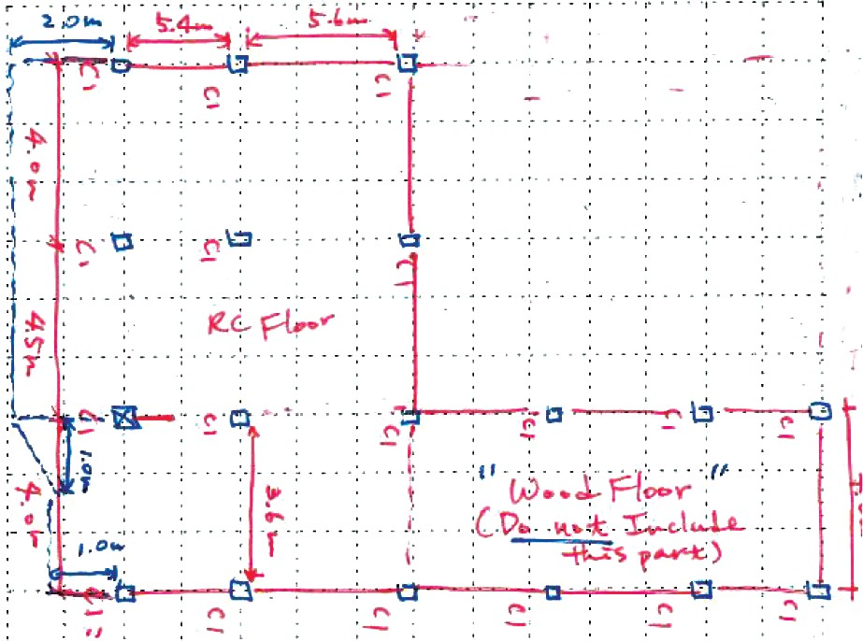
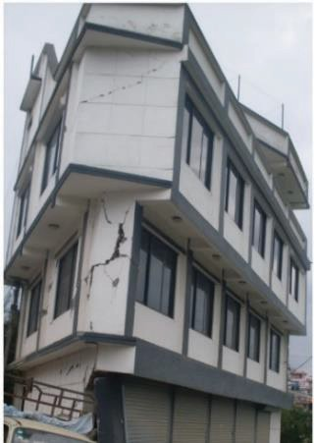
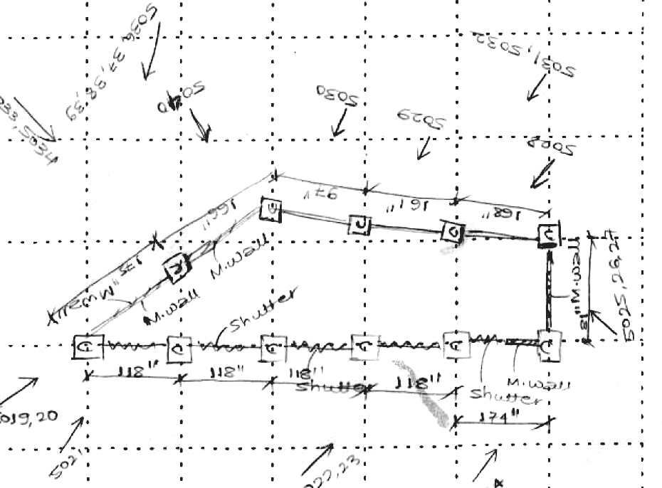
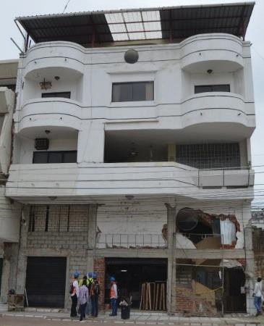
evaluation of existing RC buildings, it is necessary to quantify and consider a reduction factor associated with horizontal irregularities.
Most researchers consider the horizontal irregularity factor as a qualitative approach. Some of them are trying to quantify the horizontal irregularity factors for seismic capacity evaluation. Al-Nimry et al. (2015) propose a reduction factor for horizontal irregularity of 0.95 and 0.9 for low-rise and mid-rise buildings respectively based on different types of shapes of buildings. However, JBDPA (2001) proposes guidelines for different criteria of plan irregularity and a reduction factor for modifying the seismic capacity. The values have been considered as 1, 0.9, and 0.8 for regular, nearly regular, and irregular, respectively.

  - Building with L shaped floor plan

  - Floor plan with large aspect ratio

Figure 2.11 Damage due to horizontal irregularity of RC buildings in Nepal and Ecuador Earthquake

24

The factors are considered depending on different possible shapes of building plans (i.e., L, T or U-shaped). All types of horizontal irregularities are not easy to investigate during visual inspection. Therefore, only building configurations considering different possible shaped building plan (i.e., L, Tor U-shaped) is considered in this method. JBDPA (JBDPA 2001) is classified into three categories according to the floor plan. The basic criteria for each parameter are described in JBDPA manual (JBDPA 2001), and the brief descriptions of plan regularity are shown in Figure 2.12. The following considerations are taken for plan irregularity:

- Regular: Structural balance is good, and the area of a projection part (a) is not more than 10% of the floor area.
- Nearly Regular: Structural balance is worse than regular, or the area of a projection part
  - is not more than 30% of the floor area with an L, T, or U-shaped plan.
- Irregular: Structural balance is worse than nearly regular, or the area of a projection part
  - is larger than 30% of the floor area with an L, T, or U-shaped plan.

Length of
b b
h 1 h !

Main part
Main part
I
Length

short side of short
side
l l
b2 b2

    - L-shaped floor plan

Length of] short side
Main part
l
    - T shaped floor plan

b

Length a
of short h
side I
Main vart







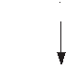










































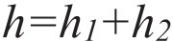
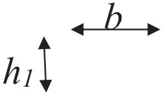
I

    - T shaped floor plan (d) U-shaped floor plan

Figure 2.12 Criteria for plan irregularity

25

Table 2.4 shows reduction factors for different horizontal irregularity factors based on the Japanese seismic evaluation standard (JBDPA 2001).

Table 2.4 Factors for horizontal irregularity (Fm)

Items Shape
Regular Regular
Nearly Regular Irregular

L, T, or U-shaped plan. L, T, or U-shaped
plan

The projection :S 10 % of floor area :S 30% of floor area > 30% of floor area area "a"
Fm 1.0 0.9 0.8

26

      - Modification factor for deterioration of concrete (Fv)

Table 2.5 shows the values of reduction coefficient due to the presence of visible crack in the buildings according to JBDPA 2001.

Table 2.5 Deterioration Factor (Fn)

Item | None | Minor | Severe
Criteria | No deterioration | Some cracks in  structural element or minor spalling | Major Spalling  in concrete and major crack
Fn | 1.0 | 0.9 | 0.8

      - Modification factor for year of construction (Fy)

In VR method modified values as shown in Table 2.6 has been considered upon construction practices, design criteria and enforcement of Building Code in Bangladesh.

Table 2.6 Year of construction factor (Fy)

Item Criteria
Fy
New After 2006
1.0
Middle 1993-2006
0.95
Old Before 1993
0.9

[Commentary 5]

Reduction Factors Related to Deterioration and Age of the Building

Generally, the seismic capacity of the existing building is reduced due to deterioration caused by poor maintenance, quality of existing buildings, and age of the building. The proposed Visual Rating Index also considers those reduction parameters.

27

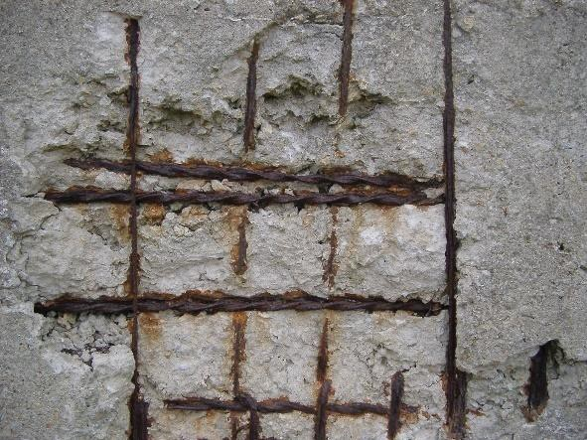
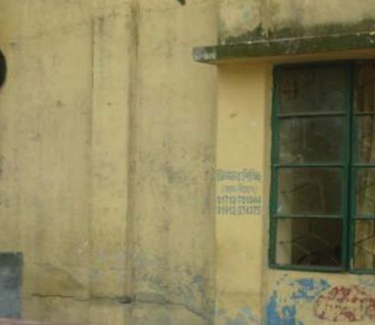

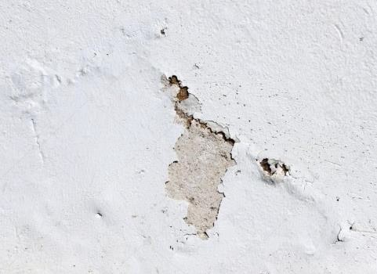
(5-1) Deterioration factor (FD)
Deterioration of concrete in structural elements strongly affects the actual state of seismic capacity of the building. Theoretically, the presence of cracks as well as spalling in concrete are responsible for the degradation of seismic capacity. This also refers to a building that can be attributed to weak material and poor workmanship. Furthermore, the correlation between the building quality and damage state has been observed based on the study of past earthquake damage databases (Sucuoglu et al. 2007).
Figure 2.13 shows typical cracks in existing RC structures which can be easily identified by visual inspection.

(a) Spalling of concrete and rebar rust (b) Crack through RC column

Figure 2.13 Deterioration of concrete
Figure 2.14 shows typical cracks in existing RC structures which can be easily identified by visual inspection. However, these types of cracks are not suggested to consider during visual inspection.

c) Crack in masonry infill d) Deterioration of plaster Figure 2.14 Deterioration of concrete and masonry infill
28

Table 2.7 shows the values of the reduction coefficient due to the presence of a visible crack in the buildings according to JBDPA 2001.

Table 2.7 Deterioration Factor (FD)

Item None Minor Severe

Criteria No deterioration

Some cracks in structural elements or minor spalling
Major Spalling in concrete and major crack

1.0 0.9 0.8

(5-2) Building's year of construction factor (Fy)
The year of construction refers to the age of the building which reflects the quality of construction as well as the design procedure adopted for a particular building. Generally, an older building cannot be expected to have a good performance during earthquakes due to old construction practices ignoring seismic detailing employed in the recent building codes. For example, in Japan, poor seismic performance has been observed in older buildings, in the 1995 Kobe earthquake, especially in those constructed before adopting the new seismic design code in 1981. Hence, those buildings were severely damaged due to this devastating earthquake (Ohba et al. 2000). Therefore, the building age affects its overall seismic performance. Based on experiences of past earthquakes, JBDPA (2001) proposed a capacity reduction factor in the seismic evaluation manual for the year construction of a building or its aging. In the VR method, modified values as shown in Table 2.8 have been considered upon construction practices, design criteria, and enforcement of the Building Code in Bangladesh.
Table 2.8 Year of construction factor (Fy)

Item Criteria
Fy
New After 2006
1.0
Middle 1993-2006
0.95
Old Before 1993
0.9

The aforementioned assumed values for each parameter in Eq. (2.2) could be adjusted for each country based on suitable characteristics of buildings and materials strength properties in that region.
29

CHAPTER 3: Application of Visual Rating Method

  - General

This chapter contains instructions for the application of the Visual Rating method and procedure of completing the VR survey datasheet during field investigation.

  - Data Collection using Survey Datasheet

Completion of the survey data sheet is one of the major tasks for the application of the Visual Rating method. This method considers a rapid inspection of buildings over a short period of time. The survey datasheet is attached below with detailed instructions for each element of the sheet.

31












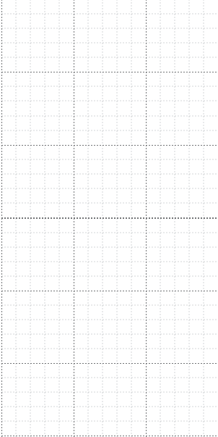




Visual Rating (VR) Survey Sheet
Legends:
---
Masonry wall (125mm) Masonry wall (250 mm)
RC wall
�
□ RC column
With opening

General Information
Building ID:
Address: |  | Zip code |  | Date: | (day/month/year)
Occupancy  Categories: | Construction  Year | Latitude: |  | Time:
Occupancy  Categories: | Construction  Year | Longitude: |  | Time:
Please read carefully the selection criteria and put circle Io] in the appropriate items

No | Items | Selection Criteria | Categories of Data |  |  |  | Note
 | No of story (n) | Put story number
2 | Average column size  (b,),(mm) | Please exclude:  (i) 50 mm for plaster, (ii) 75 mm for tiles work.
 | Average span length (/,),(mm) | The size of equivalent square floor area carried by a single column | □ □
4 | RC wall ratio | Shear wall ratio, Rsw:  NoofRCshearwall inxorydir.  Total no of span inx orydir. | X- direction: □  □ |  | Y-direction: □  □
 | Masonry infill ratio | Masonry infill Ratio, R₁-.r:  No of infill panel in x or y dir. Total no of span in x or y dir. | X-direction: □ |  | Y-direction: □
 | Vertical irregularity (F,v) | Regulac= No irregularity | Regular (I) | Nearly regular (0.8) |  | Irregular (0.6)
 | Vertical irregularity (F,v) | Nearly Regulac= Small opening at ground floor
 | Vertical irregularity (F,v) | lrregulac= Ground floor openin&'parking
 | Horizontal irregularity (F111) | Regulac= No irregularity | Regular  (I) | Nearly regular (0.9) |  | Irregular (0.8)
 | Horizontal irregularity (F111) | Nearly Reb'l!iac= Small projection exists with  irregular shape
 | Horizontal irregularity (F111) | Irregular= large projection with irreb,1Ular shape
 | Deterioration of concrete (F₀) | None= No deterioration | None  (I) | Minor (0.9) |  | Severe (0.8)
 | Deterioration of concrete (F₀) | Minor= Some crack in structrual element
 | Deterioration of concrete (F₀) | Severe= Spalling of concrete and major Crack
 | Year of construction  (F,) | New= Construction year after 2006 | New  (I) | Middle (0.95) |  | Old (0.9)
 | Year of construction  (F,) | After 1993 and before 2006
 | Year of construction  (F,) | Before 1993
*numeral in parenthesis indicates corresponding weightage

Please draw a sketch the RC column with Masonry infill

y
I X

32
Name of the Surveyor: | IVR score :I Comments
Name of the Surveyor: | Buildings category :

  - Parameters of VR Survey Data Sheet

The surveyor should complete the sketch of the building showing the location of columns, masonry infill, and RC walls. Necessary dimensions can be written as per requirements. Qualitative sketches of front and side elevation are suggested to draw. This shall be done by visually observing the building and noting its number of stories and shapes. Several snaps/photographs of the building indicating floor, front elevation, and side elevations shall be taken by the surveyors during the survey. During the completion of the VR Sheet, double writing/overwriting should be avoided in order to remain free from any confusion. If any special case appears, the surveyor shall mention it on the right side of the sheet on the column named "Note".
In the following sections, each parameter of the survey data sheet 1s discussed with consideration as follows:

    - Number of Stories (n)

The number of stories is directly related to the total building weight. The Surveyor shall input the total story number at present. If there is a difference in the number of story observed in a building or setback in the same building; the surveyor shall take the maximum story number excluding the "Chilekotha". However, surveyors have to mark the part and story number in the rough sketch of the VR Survey Sheet accordingly.

    - Average column size (be)

In this method, the cross-sectional area of the column is simplified by using representative column size (be) instead of measuring all column area of a building. The average size of columns (be) represents a dimension of a single column which reflects the dimensions of all columns of an investigated building. This proposed method requires the inspectors to enter the building and investigate columns by visual inspection.
The average column size (be) shall be chosen based on the following procedure:
- First of all, surveyors shall investigate comers, exterior columns, and interior columns. Based on the dimension of these three columns, the average column size (be)can be estimated using Eq. (3.1).
33

be= Ja1+:2+a3 (3.1)

a1, a2 and a3= Cross-sectional area of comer column, exterior column and interior column. Figure 3.1 illustrates the columns to be investigated.
w w

w
D D □
w Interior

(a1)

D ··.column (a2) □.
D D
w
w w w w
Exterior column (a3)
w

W=Window, D=Door

Figure 3.1 Schematic floor plan of a building for option 1

- If it is not easy to find the dimension of the comer column and exterior column, the surveyor shall consider representative column size (be) based on investigating three interior columns and consider Eq. (3.1). mentioned above. An example has been shown in Figure 3.2.

w w Interior
w column (a1)
D □.
w
D □.
w

wll

w
w ..· w
Interior D
column (a3)
w

wll
w









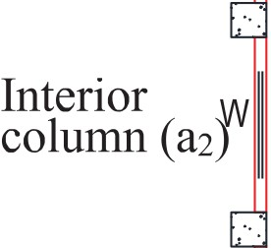

X W=Window, D=Door

Figure 3.2 Schematic floor plan of a building for option 2
It has been suggested to surveyors that they exclude plaster and tiles as follows:
- 50 mm plaster width shall be excluded while computing the average column size (be).
- In the case of tiles work, the thickness of tiles should be taken of 75 mm. The tile thickness should be deducted from the column dimension

34

    - Average Span Length (ls)

The average span length, ls is considered as the size of an equivalent square-sized floor area, the load of which will be carried by the representative column. The average span length is related to the total floor area. It was not easy to measure the floor area by visual inspection within a short time. Because it requires as-built drawing preparation if architectural drawings are not available, this takes a long time for the building survey. To determine the average span length, the surveyor shall follow the following ways.
- If it is possible to measure the length (L) and width (B) of the buildings as shown in Figure 3.3.
ls=� (3.2)

Where, L=Length of building B= Width of building
nc= Total number of columns in a story
L

w . . w . . •, w ..

w wll
•, D r· _{DC} □.
w wJJ ca

. . D . .
'L.J.. □. . .
D D

y w wJI

. . w
. . w r::'· w
. . w ..


x W=Window, D=Door

Figure: 3.3 Schematic floor plan of a building for option 1.

- If it is not possible to measure the whole area of existing buildings, Surveyor should measure at least three tributary areas as shown in Figure 3.4 such as A1, A2, and A3 for the comer column, exterior column, and interior column respectively. The average span length will be calculated using the following Equation;

35

ls= JA1 +�2+A3 (3.3)

Where, A1=Tributary area of Corner column A2= Tributary area of exterior column
A3= Tributary area of interior column
□ =w 0 . w Ot=====□ 0 .

□ 0 . 0 .

0 . D 02222222222222222222220
D

y
0 . 0 .
D

wll

0 . w
x W=Window, D=Door
0 . w 0 . 0 .

Figure: 3.4 Schematic floor plan of a building for option 2

- If it is not possible to measure the tributary area mentioned above, the surveyor is suggested to measure the length of two or three spans in both directions and the average span length is calculated using the Equation Figure 3.5 shows an example of the inspection procedure of the average span length (ls) of a surveyed building.

□ =w

lw
D. = D D D.

□ D D.

llw
D. A2 D D.

D. D

_{y} llw w
D. D.
w l w wll
D

D. =
-x W=Window, D=Door
D. . = D.


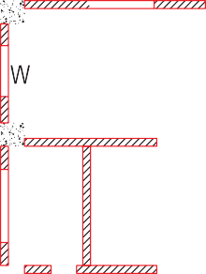
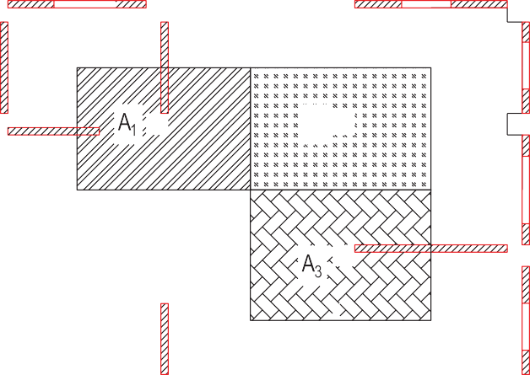
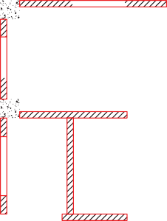


Figure: 3.5 Schematic floor plan of a building for option 3

36

    - Masonry Infill Ratio (R;,,1)

This section explains the simplified procedure of calculating masonry infill ratio using simple parameters depending on visual inspection. Generally, two types of masonry infill are commonly found in existing RC buildings: masonry infill without opening and with opening due to door, window, and high window. Sometimes, partial masonry infills with corridors are also found in existing buildings. It is not easy to measure the length and width of each masonry infill either solid or with an opening by visual inspection within a short time. On the contrary, it is easy to count the number of masonry infill panels in each direction by visual inspection instead of measuring the dimension of each masonry infill. Thus, the sectional area of masonry infills can be easily estimated using the number of infill panels, average span length (ls), and thickness of masonry infill (tin/) in each direction. Hence, the masonry infill area ratio can be simplified by using the masonry infill ratio (RinJ), the thickness of masonry infill (tin/) and average span length (ls) as shown in Eq. (3.4).

J. = Ainf � tinf R-
mf A l • mf
f s
(3.4)

where Rinf is the masonry infill ratio which indicates the quantity of masonry infill expressed as the ratio of the total number of solid masonry panels in a direction to the total number of spans for that direction.

Therefore, the masonry infill ratio (RinJ) is simplified as expressed by Eq. (3.5).
R. = Numberof masonrypanelsinadirection mf Totalnumberofspansinadirection

(3.5)

Since the proposed method considers visual inspection, the surveyor is suggested to count the number of solid masonries infills and spans for both directions in the inspection. Afterwards, the masonry infill ratio, Rinf shall be calculated for both orthogonal directions. Finally, the minimum value of Rinf is used for conservative evaluation.
Note: Since the proposed method is based on visual inspection with limited time, it should be noted that the partial infill or infill with opening due to door, and window is not considered in this method. Therefore, only solid masonry infills are considered to estimate the masonry wall area for the conservative side. Figure 3.6 shows an example of different types of opening. In addition, the solid infill outside the RC frame shall not be shall not be considered. Masonry infill enclosed by RC frame wall (Fig. 3.6a) shall be considered.
37

- Solid infill (to be considered in RinJ)

(d) Infill with central window

(g) Infill with door (side)
- Infill with high window (c) Infill with cont. window

(e) Infill with side window (f) Infill with door (central)

(h) wing wall (i) wing wall

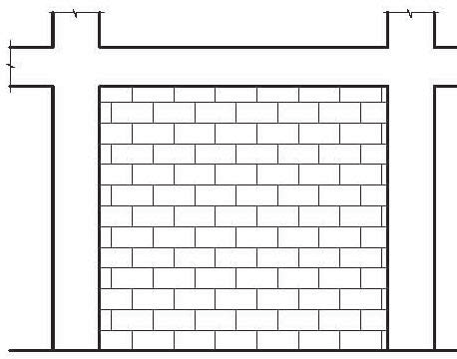
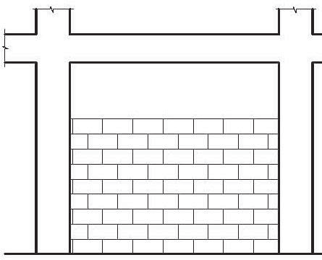
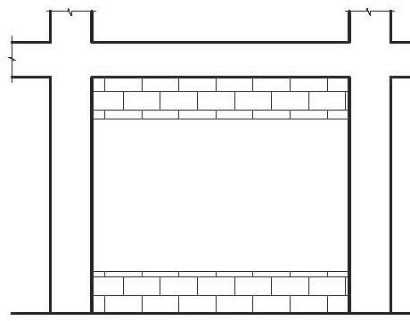
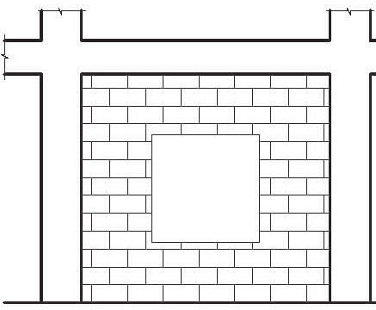
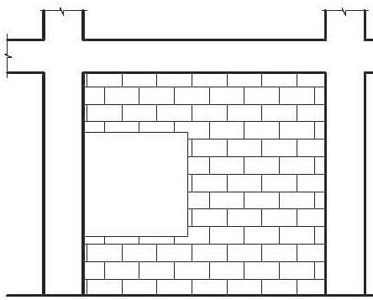
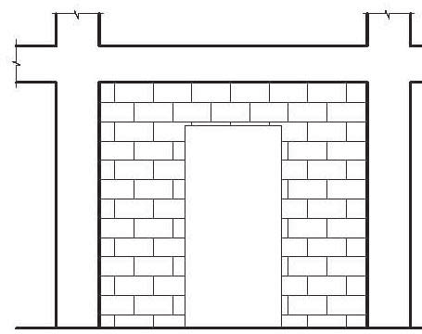
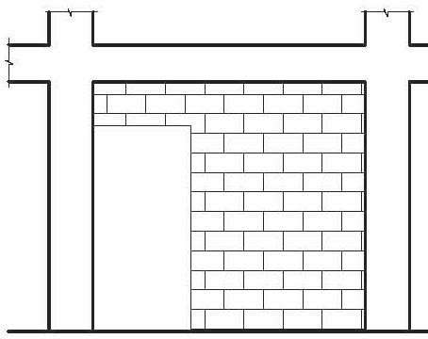
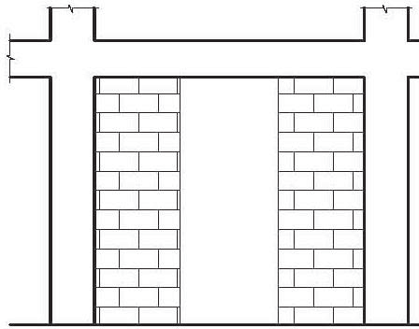
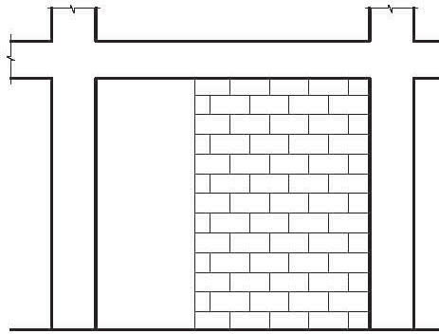
Figure: 3.6 Masonry infill with different types of opening.

A typical floor plan is shown in Figure 3.7 as an example of the calculation procedure of simplified masonry infill wall ratio (RinJ). As described in the previous sections, masonry infills with openings are not considered in this method. Therefore, the numbers of solid masonry infill panels are 2 (marked by a square) in X direction and 3 (marked by a circle) in Y direction as shown in Figure 3.7. On the other hand, the total number of spans are obtained as 16 (4 spans x 4 frames) and 15 (3 spans x 5 frames) in X and Y directions, respectively. Therefore, Rinf are

38

found 2/16 and 3/15 in X and Y direction, respectively. Here, the minimum Rinf value of 2/16 is considered for capacity prediction.

w w
w
D

lw
D
D

y w w
X
w
w
□
w

D
D
w
w w
W=Window, D=Door

Figure: 3.7 Typical floor plan showing location of masonry infill.

    - Concrete Wall Ratio (Rew)

The concrete wall area ratio (few) has been simplified by using a similar way to the masonry infill area ratio (ltnJ) as discussed in the previous section. Therefore, the concrete wall area ratio (few) is simplified with the concrete wall thickness (tcw) and the average span length (ls) as shown in Eq. (3.6).
(3.6)

where the concrete wall ratio (Rew) indicates the number of concrete walls expressed as the ratio of the total number of solid concrete wall panels in a direction to the total number of spans for that direction as shown in Eq. (3.7).

R = Numberof concretewallsinadirection cw Totalnumberofspansinadirection
(3.7)






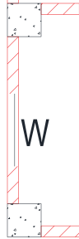
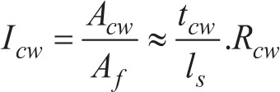
Concrete walls with openings due to doors and windows are not considered in this method as a conservative approach. Rew shall be calculated for both orthogonal directions and the minimum value is considered.

39

    - Modification Factor

      - Vertical Irregularity Factor (Fw)

This factor aims to check the balance of story stiffness distribution along with the height, the inconsistency between adjacent floor, ground floor parking, soft-story etc. Detailed information is described in articles 2.4.3 and 2.4.3.1 of Chapter 02.

      - Horizontal Irregularity Factor (FIH)

Sometimes a high aspect ratio of floor plan (here aspect ratio means the ratio of building's length between longitudinal to transverse direction) might exist in a building, and this type of building has been reported to experience severe damage during past earthquakes based on past earthquake damaged database. Detailed information has been described in articles 2.4.3 and
2.4.3.2 of Chapter 2.

      - Deterioration Factor (FD)

Deterioration of a building has an impact on its structural performance. So, it is important to identify if there is any type of deterioration and judge the significance of such damage. Detailed information has been described in articles 2.4.3 and 2.4.3.3 of Chapter 02.

      - Building's year of construction Factor (Fy)

Building construction year i.e., building age reflects the quality of construction, concrete strength as well as the design procedure adopted for a particular building. Therefore, building age affects its overall seismic capacity. The approximate age of a building can also indicate the possible structure type. The ability to identify the age of a building by considering its architectural style and construction materials requires extensive knowledge of architectural history and past construction practice. In the case of phased construction, starting time of the first phase shall be taken into consideration. Detailed information has been described in article
2.4.3.4 of Chapter 02.

40

    - Sketch of Floor Plan

A preliminary sketch of the floor plan has to be drawn at the bottom of the VR survey sheet. However, it does not have to be a properly scaled drawing. The main purpose of this rough sketch is to have a preliminary idea about the floor plan, frames/framing system, and location of solid masonry walls. Later this sketch will be used to calculate Rinf. The surveyor must sketch the plan as clearly as possible for future reference. It is suggested to draw the front and side elevation of the building to understand the story number and vertical irregularities. It should be emphasized that several photographs should be taken to reassess the obtained data and for further verification.

  - Inspection Procedure

VR is basically intended for rapid screening of a large number of building stocks. So, detailed inspections are not required. However, if a surveyor thinks it necessary, detailed inspections may be carried out with the use of proper instruments. Simple measuring instruments like steel tape, scale, laser meter, rebar detector, etc. shall be used to determine the parameters. The surveyor should try his best to get the closest values of the parameters.
VR Index Calculation requires only the inspection of the ground floor and first floor. Parameters like column size, span length, and Masonry Infill Ratio shall be obtained only from the ground floor. The reason behind this is that the ground floor is typically the most vulnerable to seismic incidents. However, to understand the frame system, the possibility of the soft story and other vertical/horizontal irregularities, or any other technical reasons necessary to fill up the VR survey form, surveyors may also need to survey other floors.

Two engineers have been considered for the building survey. The surveyors should take necessary actions to ensure entry at all essential locations for the survey of the building. For this reason, they might ensure the schedule 2 to 3 days before the inspection. If the surveyors cannot take some parameters due to any restriction, they will note other data such as photos for indication of survey parameters, but not complete the survey. Irrational assumptions without confirmation are not encouraged.
The surveyors should be capable of understanding the whole picture of the ground floor as well 41

as the frame system. If there is a possibility of a serious pounding effect, the surveyors might include it somewhere in the survey sheet.

3.5 Guidelines for Filling up the Survey Data Sheet

In this section, the procedure for filling up the survey datasheet will be discussed step by step.

Step 1: General Information:

- Surveyors will input the survey date, surveyed building's name, and its address at the top of the survey data sheet as shown in Table 3.1.
- Surveyors will write their names in the place of the Name of the Investigator located at the bottom of the sheet as shown in Table 3.2.
- If possible, surveyors will collect structural/architectural drawings of the building.

Table 3.1 General information of survey datasheet

Table 3.2 Investigator's name in survey datasheet

I Name of the Investigator: I
!YR score: I Comments:
Buildings category:
I

Visual Rating (VR) Survey Sheet
Building ID: XXX
Building Name: YYYY Address: ZZZ
Date: xx/yy/zz
Time: 0:00
Latitude: Longitude:
Occupancy Categories: Residential
Zip: 000- 000000
Construction Year:

Step 2: Number of Stories
Surveyors will count the story number from outside of the building. They will also write the category of the building i.e., in which purpose the building is currently used like residential/official/educational/institutional etc.

42

Figure:3.8 Front View of the Building Showing Number of Stories

Here, the illustration in the Figure 3.8 shows the front view of the building. There is a difference in the number of stories in the same building. In this case, the largest number should be used for the survey and a note shall be kept for this story difference with a rough sketch.

Table 3.3 Building category, number of stories, and other information in survey datasheet.

No.
Items Selection Criteria
Categories of Data I Note

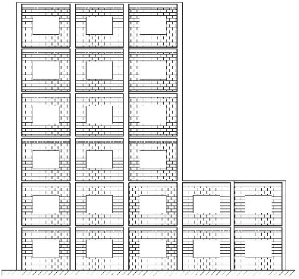
1 | Number of  Stories (n) | Put Story number | 06 (Six) | Part of the  building is 2 (Two) Storied

Step 3: Drawing Rough Sketch of the Building

Surveyors will draw a rough sketch of the building. In this sketch, surveyors are suggested to draw the location of columns, solid infill masonry walls, and concrete walls. Masonry walls with openings are not included in the calculation of the VR index. Therefore, surveyors may neglect them. But in this case, they should mention if the ground floor is open or not to avoid any misunderstanding. In the rough sketch, the surveyors may also include column size, and span length for later judgment. But the rough sketch shall be as neat as possible to get the useful information for the VR method as shown in Figure 3.9.

43

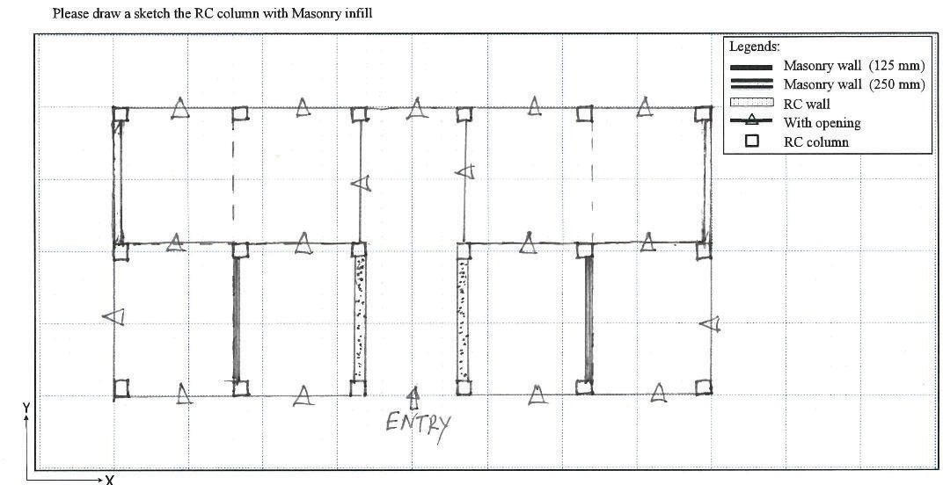

Figure 3.9 Rough sketch of the building showing Column layout and masonry walls with/without opening

Step 4: Average column size (be)

For selecting average column size, the surveyors shall follow section 3.3.2. According to section 3.3.2, the surveyor shall follow option one, if the comer and exterior column can be measured. Otherwise, the surveyor can measure the interior column and follow the second option.
An example has been given below in Figure 3.10. For this building, it is possible to measure the dimension of a comer (a1), exterior column (a2), and interior column (a3). Therefore, the average column size has been found calculated using Eq. (3.3). The calculation procedure has been given as follows:
Comer column, a1 =300 mm X 300 mm Exterior column, a2= 300 mm X 375 mm Interior column, a3=375 mm X 400 mm,
Hence, the average column size= 350 mm (After excluding mortar thickness)
Surveyor shall fill the dimension in the No.2 item in the survey data sheet accordingly as shown in Table 3.2.

44

0
oo

Figure 3.10 Selecting three columns from the column layout of the building for Average Column Size.

Table 3.4 Average Column Size (be) in survey datasheet
I Note I

� Items
2
Average  column size,  (be), (mm) | Please exclude:  - 50 mm for plaster,  - 75 mm for tiles work. | 350

Selection Criteria
Categories of Data

Step 5: Average Span Length (ls)
For selecting average span length, surveyors shall follow section 3.3.3. First of all, it is preferable to go with the first option. If the surveyor can measure the total building's length and width, then the surveyor can go through the first option for calculating the average span length of the building. Otherwise, the surveyor can follow options 2 and option 3.
Figure 3.11 has been shown the calculation procedure for the surveyed building. In these buildings, it is possible to measure the total building length in both directions. The average span length can be estimated using the Equation mentioned in Chapter 2.
The calculation procedure has been given as follows: Where, L=Length ofbuilding=20700 mm
B= Width ofbuilding=9800 mm
Ncal.L= Number of columns in long direction=6
Ncal.B= Number of columns in short direction=3

Average span length, ls= ²⁰⁷⁰⁰ X 9800
J
6x 3
=3357 mm;:::3::250 mm

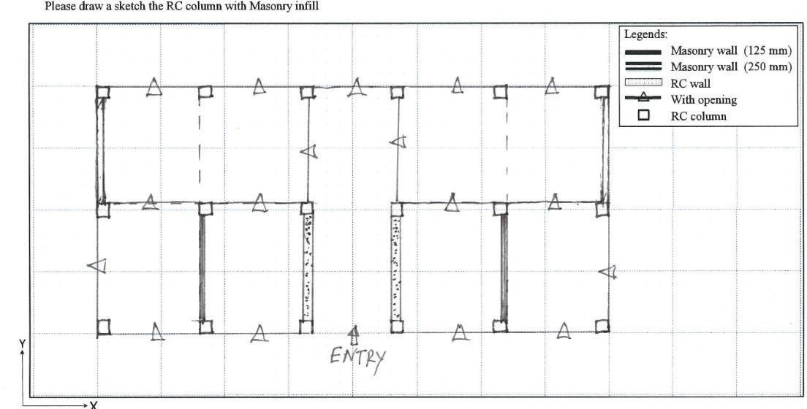
Assume, 3000 mm for conservative estimation.
45

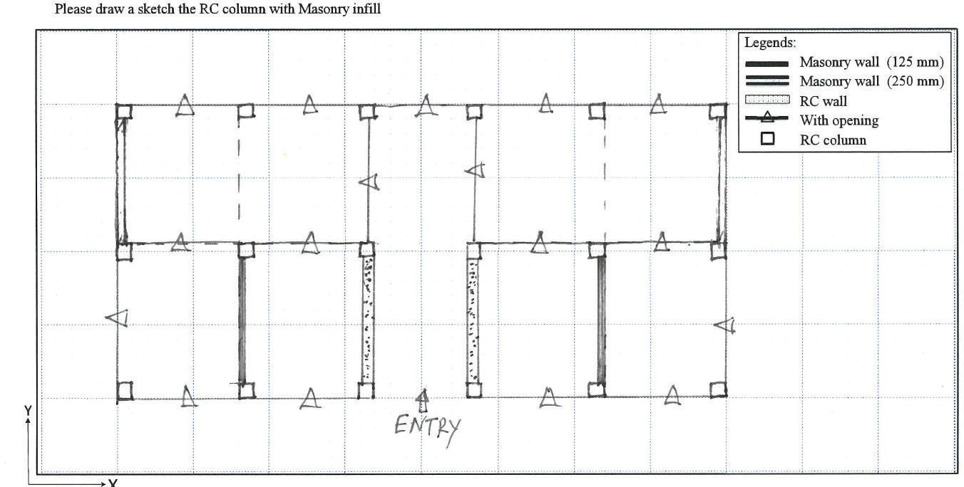

Figure 3.11 Selecting average span from column layout of the building

Table 3.5 Average span length (ls) in the survey data sheet
LJ
3
Items | Selection Criteria | Categories of Data | Note
Average span  length (ls),  (mm) | The size of equivalent square  floor area carried by a single column | 3250

Step 6: Masonry Infill Ratio (RinJ)

For calculating the masonry infill ratio, Rinf, several masonry infill walls in the frame in each direction shall be counted and divided by the total number of spans of that respective direction. It should be noted that infill panels connecting adjacent frames shall only be counted. Walls with openings like doors and windows shall not be included.

46

SI SI

SI SI

SI = Solid Infill

Figure: 3.12 Sketch showing the number oflnfill walls with or without openings

For example, in Figure 3.12, the total number of spans in X-direction is 15 (5 spans x 3 frames). But there are no solid infill walls in X-direction. So, the masonry infill ratio in the X-direction
will be�- Similarly, the total number of spans in Y-direction is 12 (2 spans x 6 frames). The
15
number of 125 mm solid infill is 2 and that of 250 mm solid infill is 2. So, the total number of solid infill masonry walls is 6 (2*2+2 = 6), counting 250 mm solid infill twice. So, the masonry
infill ratio in y-direction will be� excluding the wall with an opening. The following shows
12
how to complete this part of the survey datasheet.

Table 3.6 Masonry Infill Ratio (RinJ) in the survey data sheet
LJ
4
Items | Selection Criteria | Categories of Data |  | Note
Masonry Infill Ratio, | Masonry Wall Ratio, Rinf"  NumberofinfillpanelsinXorYdir. totalnumberofspansinXorYdir. | X-Direction:�  15 | Y-Direction:�  12

Step 7: Concrete Wall Ratio (Rew)
Likewise, the masonry infill ratio, for calculating concrete wall ratio, Rew, the number of concrete walls in the frame in each direction shall be counted and divided by the total number of spans of that respective direction. It should be noted that the concrete wall connecting
47

adjacent frames shall only be counted. Walls with an opening like doors and windows shall not be included.

Figure: 3.13 Sketch shows the number of concrete walls with or without openings.

In this Figure 3.13, the number of shear walls in X-direction is O (zero), and that of the span's is 15.
Again, the number of shear walls in Y-direction is 2 (Two) and the number of spans is 12.
Rew (X-dir.) = 0/15
Rew (Y-dir.) = 2/12
The following shows how to complete this part of the survey datasheet.

LJ Items
5
Concrete  wall ratio, | Concrete Wall Ratio, Rew-  NumberofConcretewallsinXorYdir. totalnumberof spansinX orY dir. | X-Direction:�  15 | Y-Direction: 2-  12

Table.3.7 Concrete wall ratio in the survey data sheet

Selection Criteria Categories of Data

Note

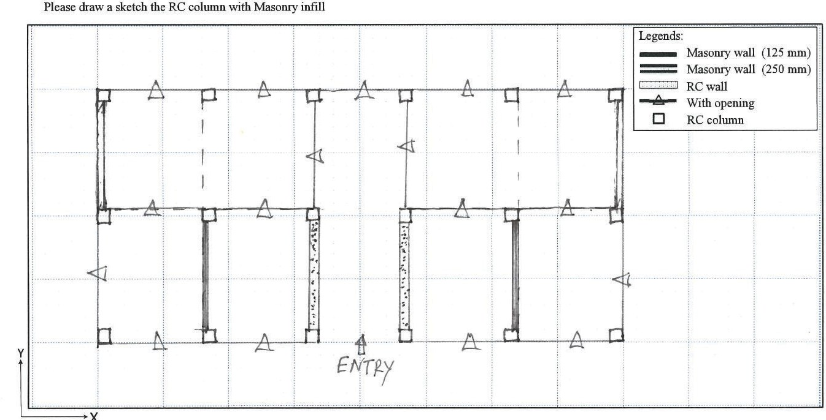

Step 8: Vertical Irregularity

Surveyors shall follow section 2.4.3.1 in Chapter 2 to determine if there is any vertical irregularity in the building. If the surveyors cannot determine the vertical irregularity on their

48

own, they shall draw a rough sketch of the building showing necessary elevations of the building so that a higher supervising authority can judge the building frame system. From the front view of the building in Figure 3.8, the building has a setback and it is one kind of irregularity. In the survey datasheet, reduction factors for vertical irregularity are mentioned for various cases in section 3.4. A surveyor should tick or encircle the case that most fits the building. For the case in Figure 3.8, the data sheet shall be like the following:

Table 3.8 Vertical irregularity in survey datasheet

�
Items | Selection Criteria | Categories of Data |  |  | Note
Vertical  irregularity, | Regular= No irregularity | Regular | Nearly | Irregular | Keep | Note | if
Vertical  irregularity, | Nearly Regular= Small opening | (1) | Regular | (0.6) | there IS any
FIV | on the ground floor |  | (0.8) |  | confusion
 |  |  |  |  | (Along with the
 | Irregular= Ground Floor Open/
 | Parking |  |  |  | sketch)

161

Step 9: Horizontal Irregularity

The surveyor shall follow section 2.4.3.2 in Chapter 2 to determine if there is any horizontal irregularity in the building. If the surveyors cannot determine horizontal irregularity on their own, they shall draw a rough sketch of the building showing the necessary plan and projection of the building so that a higher supervising authority can judge the building frame system. The example building plan shown in Figure 3.1 represents a regular shape of a building. In the survey datasheet reduction factor for horizontal irregularity are mentioned for various cases. For this building, surveyors shall encircle "Regular" for item no.7.

H Items
 | Selection Criteria | Categories |  |  | Note
Horizontal  irregularity,  FIH | Regular= No irregularity | Regular Nearly I Irregular |  |  | Keep Note if  there IS any confusion (Along with the sketch)
Horizontal  irregularity,  FIH | Nearly Regular= Small projection  exists with an irregular shape | (1.0) | Regular  (0.9) | (0.8) | Keep Note if  there IS any confusion (Along with the sketch)
Horizontal  irregularity,  FIH | Irregular= Large projection exists  with an irregular shape

Table 3.9 Horizontal irregularity in survey datasheet

49

Step 10: Deterioration and Year of Construction

Judgment of deterioration is sometimes very crucial. It takes extensive knowledge and vast experiences to understand whether the deterioration is considered structural or non-structural. Surveyors may identify several common types of deterioration as mentioned in section 2.4.3. If it is difficult to make a decision about reduction factor for deterioration, surveyors shall take photos of the damaged location for a better understanding of their supervising authority.
Similarly, for year of construction, the surveyors shall lookup for the drawing and construction time. If the drawing is not available, the surveyors may take information from the owner. If that is also not possible, they shall take as many pictures as possible for understanding the architectural pattern and construction practice and notify their supervising authority. However, a precise year of construction is not a must as the range is given in the datasheet.
In the survey datasheet, item number 8 and item number 9 represent the factors deterioration of concrete, FD and year of construction, Fy. For a new building with some minor cracks on a structural element such as a beam or column, the survey datasheet shall be as follows:

Table 3.10 Deterioration of concrete, FD and Year of construction, F y
Items | Selection Criteria | Categories |  |  | Note
Deterioration | None= No deterioration |  |  |  | Keep Note if
of Concrete, Fo | Minor= Some crack in  structural element or minor spalling | None (1.0) | Minor (0.9) | Severe (0.8) | there is any  confusion (Along with
of Concrete, Fo | Severe=Major spalling  of concrete and major Crack
 | Severe=Major spalling  of concrete and major Crack |  |  |  | photos)

�

r7 Yearof
Construction,
Fr | Old=Before 1993 | New  (1.0) | Middle  (0.95) | Old  (0.9) | confusion (Along with photos)

New= After 2006
I
Middle= 1993-2006

Keep �ote if I
I
there
1s any

50

Final output of the VR sheet shall be as follows:
Visual Rating (VR) Survey Sheet

General Information
Building ID: | 'X.X.X'J<.X)(.X.
Address: | xxxxx.. | Zip code | XX X-Xi->< | Date: | xx;, yy /Z"Z-  (day month/year)
Occupancy Categories: | Xx xx I Construction I xxxx.  Year | Latitude: | ;<.' y' | Time: | xx.:xx
Occupancy Categories: | Xx xx I Construction I xxxx.  Year | Loni;:itude: | x" v' | Time: | xx.:xx
Please read carefully the selection criteria and put circle (o) in th• appropriate items
No | Items | Selection Criteria | Categories of Data |  |  |  | Note
1 | No of story (n) | Put story number | 6 (5ix..)
2 | Average column size (b,),(mm) | Please exclude:  (i) 50 mm for plaster, (ii) 75 mm for tiles work. | 350
3 | Average span length (l,),(mm) | The size of equivalent square floor area carried by a single column | 3000
4 | RC wall ratio | Shear wall ratio, R.w:  No of RC shea.r wall tn x or y d!r, | [Q]  X- directioo:  @] |  | @]  Y-direction:  [1g]
4 | RC wall ratio | Total no of span In x or y dlr.
5 | Masonry infill ratio | Masonry infill Ratio, R;,,;.  = No of infill pan�l ln x or y dlr. | [QJ  X-direction:  [ill |  | [E]  Y-direction:  [ill
5 | Masonry infill ratio | Total no of span in x or y dlr.
6 | Vertical irregularity (F1v) | Regular= No irregularity | Regular (I) | early regular (0.8) |  | Irregular (0..6)
6 | Vertical irregularity (F1v) | Nearly Regular- Small opening at ground floor
6 | Vertical irregularity (F1v) | Irregular- Ground floor opening/parking
7 | Horizontal irregularity {Fni) | Regular= No irregularity | )  � | Nearly regular (0.9) |  | Irregular (0.8)
7 | Horizontal irregularity {Fni) | Nearly Regular= Small projection exists with irregular shape
7 | Horizontal irregularity {Fni) | Irregular= large projection with irregular shape
8 | Deterioration of concrete (F0) | None>= No deterioration | None  (1) | r  � .9)  � |  | Severe  (0.8)
8 | Deterioration of concrete (F0) | Minor= Some crack in structrual elemeot
8 | Deterioration of concrete (F0) | Severe= Spalling of concrete and major Crack
9 | Year of construction  (F,) | New= Construction vear after 2006 | G(I)e0 | Middle (0.95) |  | Old (0.9)
9 | Year of construction  (F,) | After 1993 and before 2006  Before 1993
•numeral m parenthesis mdicates corresponding we1ghtage
Please draw a sketch the RC column with Masonry infill

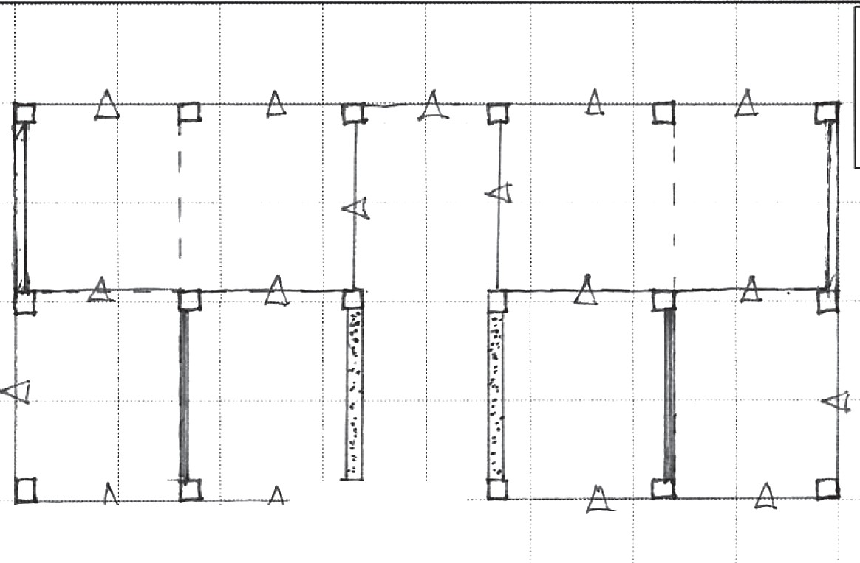
Legends:
=

Masonry wall (125 mm)

-- Masonry wall (250 mm)
RCwall
....&- With opening
D RCcolumn

11·
L_._x-----'-----'---=�=�f�N'"--'T�P-'f-'-------'�----'------'-----'----�-�---'-"-'-"

Name of the Surveyor: IVRscore Comments
Buildings category

51

3.6 Calculation of VR Index

The Visual Rating Index (lvR) is calculated by Eq. (2.1) of Chapter 2.
1
fvR =- -[,c(b{ J+ 'inf(tinf .R.,nfJ + 'cw(tcw .RcwJ]F,v.FtH"FD.FY
n.w ls ls ls
The notation of each item in equation are as follows:
re= The average shear strength of column= 1.0 MPa
Tsw =The average shear strength of shear wall = 1.0 MPa TinFthe average shear strength masonry infill= 0.2 MPa n= Number of story= 6 (Six)
w=Unit weight of buildings= 11 kNm-²
linF Thickness of masonry infill= 125 mm (Count twice if 250 mm)
tew= Thickness of concrete wall= 250 mm Visual Rating Parameters:
be=Average column size= 350 mm (Average of the encircled Range) ls=Average span length= 3250 mm (Calculated average span length) RinJ=Masonry infill ratio,= 0/15, 6/12 (Consider the minimum value, 0/15) Rew =Concrete wall ratio,= 0/15, 2/12 (Consider the minimum value, 0/15) The reduction factors are as follows:
Fn-=The modification factors for vertical irregularity= 0.8
F11--F The modification factors for horizontal irregularity = 1.0
Fo = The modification factors deterioration of concrete and year of construction= 0.9
Fy = The modification factors for year of construction = 1.0

lvR1=00-0[
lx⁽
2
-35-0 )
+ 0.2²x⁵⁰ -x⁰- + 1 ⁽

-2x50-

0 )]
x 0.8xlx0.9x1=0.12

6xll 32502
3250 15 3250 15

52

CHAPTER 4: Judgment criteria of Visual Rating index for priority setting

  - General

In general, judgment criteria are used to understand the seismic performance level of an existing building subjected to an earthquake. The buildings are to be categorized into vulnerable or not vulnerable based on Visual Rating index. The judgment criteria of Visual Rating method used in this chapter is to categorize the vulnerable buildings into less to most vulnerable buildings and these buildings are to be considered for further detailed seismic evaluation. This chapter presents the proposal of judgment criteria and boundary for each category according to Visual Rating index (I vR).
  - Judgement criteria of Visual Rating method

In this manual, the buildings are to be classified into 5 categories. Buildings are to be divided into 5 categories such as (A, B, C, D and E) as follows:
Table 4.1 Proposed boundaries for Visual Rating method

Range | Categories | Priority of detailed evaluation
0.25:S lvR | A | Least
0.20:S lvR<0.25 | B | Less
0.15:S lvR<0.20 | C | Moderate
0.10:S lvR<0.15 | D | High
lvR<0.10 | E | Highest

Commentary 1

(1-1) Introduction

Bangladesh is now adopting the Japanese seismic evaluation standard (JBDPA standard) in the PWD manual for detailed seismic evaluation of existing RC buildings (CNCRP, 2015). The PWD manual proposes judgment criteria of detailed seismic evaluation, seismic demand index (Isa), ranging from 0.28 to 0.36 based on seismic demand and seismicity in Bangladesh National Buildings Code (BNBC, 2020). In this manual, the judgment criteria of VR method are set based on seismic demand index (Isa) of detailed seismic evaluation. However, due to

53

the lack of a past earthquake database in Bangladesh, the seismic demand index (/so) proposed by the PWD Manual (CNCRP, 2015) was verified in a previous study ( Islam, MS, 2019), before using VR method. Based on the study, buildings are classified into 5 groups namely A, B, C, D, and E according to proposed judgment criteria as shown in Table 4.2. In the criteria, the buildings that have the lower seismic capacity (i.e., 1s2 less than 0.40) are considered as vulnerable buildings and E are the most vulnerable buildings. In this manual, judgment criteria of VR method are proposed using the categorization according to seismic index (1s2), and an obtained correlation between seismic index (1s2) and Visual Rating. The Visual Rating index (lvR) from the previous study (Islam, MS, 2019).
Table 4.2 Judgement criteria according to seismic index (1s2) (Islam, MS, 2019)

Seismic index (/s2) | Categories | Description
0.50~ | A | No damage
0.40~0.50 | B | Light damage
0.30~0.40 | C | Less possibility of collapse
0.20~0.30 | D | Moderate possibility of collapse
<0.20 | E | High possibility of collapse

(1-2) Boundaries for judgment criteria
Since the proposed VR method is a preliminary evaluation by visual inspection and the main target is to screen all the vulnerable buildings, it is acceptable if not vulnerable buildings are to be identified as the vulnerable buildings (such as in categories C to E). However, the number of not vulnerable buildings within these categories (such as in categories C to E) should be as few as possible. For this instance, a correlation between cumulative distribution of buildings (in percentage) for each range of seismic index (1s2) and Visual Rating index (IvR) is developed in the previous study (Islam, MS, 2019) as shown in Figure 4.1.

54

<0.2 <0.3 --ls2<0.4 <0.5
100%

en
� 80%
:§
·5
60%
..D
4-<
L
90%
target

0.... 40%
(1)
"s 20%
z;:::l
0%
0 0.1 0.2 0.3 0.4 0.5
Visual Rating index (IvR)

Figure: 4.1 Cumulative percentage of buildings according to Visual Rating index (lvR)

According to Figure 4.1, this manual proposes the boundaries of judgment criteria of the VR method considering the target number of buildings (in percentages) in each category to be screened. Considering the target screening of 90% in each category as shown in Figure 4.1, boundaries of lvR are set as mentioned in Table 4.3. It has been observed that there are still some variations in each range of lvR and the difference between the range 0.24:S lvR<0.26 is narrow compared to other ranges. The reason behind this is that the number of buildings investigated within these ranges is few. It is noted that increasing the number of buildings might change the range of these boundaries.
Table 4.3 Boundaries according to different target numbers of buildings

Number of buildings (percentages) identified in each category

Visual Rating Index (lvR) ranges
90%
0.26'.S lvR
0.24:S lvR<0.26
0.16:S IvR<0.24
0.09'.S IvR<0.l 6
lvR<0.09

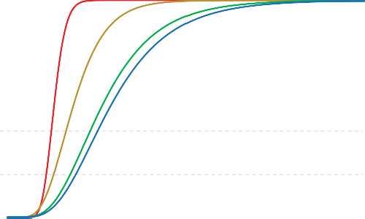



Based on the above discussion and considering the simplification of each range, boundaries of judgment criteria of the VR method are proposed as shown in Table 4.4. From the criteria, the buildings with lvR is less than 0.10, located in the E category, are the most vulnerable buildings, and a detailed evaluation is highly recommended.

55

Table 4.4 Proposed boundaries for Visual Rating method

Range | Categories | Description
0.25:S lvR | A | No damage
0.20:S lvR<0.25 | B | Light damage
0.15:S lvR<0.20 | C | Less Possibility of collapse
0.10:S IvR<0.15 | D | Moderate possibility of collapse
lvR<0.10 | E | High possibility of collapse

The buildings with Visual Rating Index (JvR) less than 0.25, are classified as C, D and E and those buildings are regarded as seismically vulnerable and might collapse during an earthquake. Besides, the existing buildings consisting of much lower Visual Rating index (IvR) (such as IvR<0.l 0) are classified into E category, have been categorized as the most vulnerable buildings and those buildings are to be considered as a higher priority for detail seismic evaluation comparing with other classes. On the other hand, the buildings with higher lvR (IvR is larger than 0.25) indicate that those buildings might not be severely damaged during an earthquake. Detail evaluation is not urgently required for those buildings with higher VR index.
It should be noted that the proposed judgment criteria have been set for Dhaka seismicity. Further, an investigation is needed for application to other seismic areas. In addition, to increase the effectiveness and accuracy of the proposed judgment criteria, further building survey and investigations of seismic capacity is required.

56

References

Alwashali, H., Islam, M. S., Sen, D., Monical, J., & Maeda, M. (2020): Seismic capacity of RC frame buildings with masonry infill damaged by past earthquakes. Bulletin of the New Zealand Society for Earthquake Engineering, 53(1), 13-21.
https://doi.org/10.5459/bnzsee.53.1.13-21.
Alwashali H., Islam, M.S., Sen, D., Maeda, M., (2019): Study on seismic capacity of existing RC buildings with masonry infill based on past earthquakes damage, JCI annual convention, :::i '/ !J !} - !---I'¥:c¥�!ilfl.X�, ffi 41 §ffi 2 %, pp.1015-1020, July
2019.
American Society of Civil Engineers (ASCE) (2007): Seismic Evaluation of Existing Buildings. ASCE/SEI 41-06.
Bangladesh National Building Code (2020): Housing and Building research institute.
Bog-azi9i University, Istanbul Technical University, Middle East Technical University, and Yildiz Technical University (BU-ITU-METU-YTU) (2003): Earthquake Master Plan for Istanbul, published by the Metropolitan Municipality of Istanbul, Planning and Construction Directorate, and Geotechnical and Earthquake Investigation Department, Turkey.
BSPP (2021): Seismic evaluation manual of existing RC buildings in Bangladesh.
Chiou TC, Hwang SJ, Chung LL, Tu YS, Shen WC, Weng PW (2017): Preliminary Seismic Assessment of Low-Rise Reinforced Concrete Buildings in Taiwan. 16th WCEE, Chile.
CNCRP (2015): Seismic evaluation manual of existing RC buildings in Bangladesh.
Donmez C, Pujol S (2005): Spatial distribution of damage caused by the 1999 Earthquakes in Turkey. Earthquake Spectra, 21, 53-69.
Federal Emergency Management Agency (FEMA P 154) (2015): Rapid Visual Screening of Buildings for Potential Seismic Hazards: A Handbook, 3rd edition, Washington D.C.
Gur T, Pay AC, Ramirez JA, Sozen MA, Johnson AM, Irfanoglu A, and Bobet A (2009): Performance of school buildings in Turkey during the 1999 Duzce and 2003 Bingol EQ. Earthquake Spectra, 25, 239-256.
Hassan, A. F., & Sozen, M. A. (1997) : Seismic vulnerability assessment oflow-rise buildings in regions with infrequent earthquakes. ACI Structural Journal, 94(1), 31-39.
Islam MS (2019): Rapid seismic evaluation method and strategy for seismic improvement of existing reinforced concrete buildings in developing countries. Ph.D. dissertation, Tohoku University, September.
Islam, M.S., Alwashali, H., Sen, D., Maeda, M. (2020): A proposal of Visual Rating method to set the priority of detailed evaluation for masonry infilled RC building, Bulletin of Earthquake Engg. 18, 1613-1634, 2020, https://doi.org/10.1007/s10518-019-00763-5.
Islam, M.S., Sen, D., H., Alwashali, Maeda, M., (2019) "Visual Rating method for seismic evaluation of existing RC buildings with masonry infill: a case study of Bangladesh", JCI annual convention, Vol. 41(2) 1009-1014, July 2019.
Islam, M.S., Alwashali, H., Torihata, Y., Maeda, M., (2018): Rapid seismic evaluation method of existing RC buildings with masonry infill based on earthquake damage", JCI annual convention,Vol. 40 (2) :::i '/ !J !} - !---I'¥:c¥��.X�, ffi 40§ffi 2 %, pp.1027-
1032, July 2018.
Islam, MS., Alwashali, H., Tafheem, Z., Maeda, M., (2020): Proposal of judgement criteria for 57

priority setting of detailed seismic evaluation of existing RC building in Bangladesh. JCI annual convention, Vol. 41(2) 1009-1014, July 2019.
Islam, MS., Alwashali, H., Maeda, M., Seki, M., Islam, M.R., Sen, D., Sikder, M.A.M, (2020) : Visual Rating method and priority setting of detailed evaluation of existing RC buildings with masonry infill, 17th World Conference on Earthquake Engineering, 17WCEE Sendai, Japan, September13th to 18th 2020, Paper no. 3a-0010.
Jain S, Mitra K, Kumar M, Shah M (2010): A proposed rapid visual screening procedure for seismic evaluation of RC-frame buildings in India. Earthquake Spectra, 26(3).
Japan Building Disaster Prevention Association, JBDPA. (2001): English version: Standard for seismic evaluation of existing reinforced concrete buildings, 2001. Tokyo, Japan.
Maeda M, Islam MS, Alwashali H, Islam MR, Seki M, Jin K (2018): A seismic capacity evaluation and priority setting for RC building with masonry infill. 16th ECEE, June, Greece.
O'Brien P, Eberhard M, Haraldsson 0, Irfanoglu A, Lattanzi D, Lauer S, and Pujol S. (2011): Measures of the Seismic Vulnerability of Reinforced Concrete Buildings in Haiti. Earthquake Spectra, 27:Sl, S373-S386.
Ohba T, Takada S, Nakano Y, Kimura H, Owada Y, Okada T (2000): Seismic capacity of existing reinforced concrete school buildings in Ota City, Tokyo, Japan. 12th WCEE, NZ, 2000.
Ozcebe G, Yucemen MS, and Aydogan V. (2004): Statistical seismic vulnerability assessment of existing reinforced concrete buildings in Turkey on a regional scale. Journal of Earthquake Engineering, 8, 749-773.
Purdue University, NCREE (2016): Performance of RC Buildings in the 2016 Taiwan Earthquake, https://datacenterhub.org/resources/14098.
Science and Technology Research Partnership for Sustainable Development (SATREPS) (2015): Project of technical development to Upgrade Structural Integrity of Buildings in densely populated Urban Areas in Bangladesh.
Shiga T, Shibata A, Takahashi T (1968): Earthquake damage and wall index of reinforced concrete buildings. Architectural Institute of Japan, No.12, pp. 29-32.
Sucuoglu H, Yazgan U, Yakut A, (2007): A screening procedure for seismic risk assessment in urban building stocks. Earthquake Spectra, 23(2).
Tsai KC, Hwang SJ (2008): Seismic retrofit program for Taiwan school buildings after 1999 Chi-Chi earthquake. 14th WCEE, China, October 2008.

58

Example building-01

Name of the building: Rehabilitation center for drug addicts
Address: Tejgaon, Dhaka.
- Pictorial Preview:

5-Storied building used for hospital purpose

Interior column with no solid wall
Double height column in front of the building

Out of frame interior wall with openings

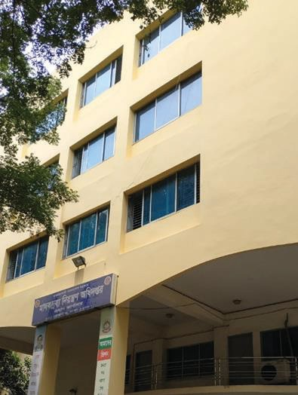
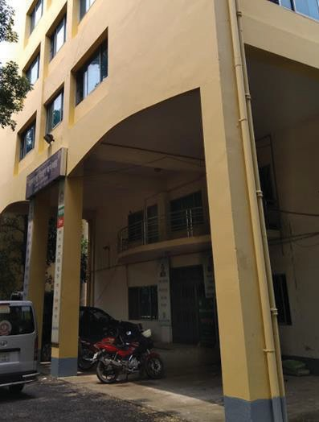
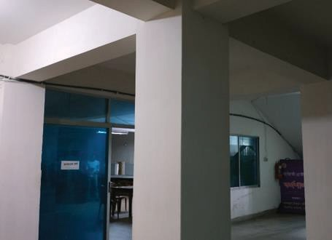
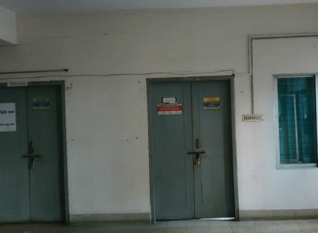

Al

- Completed VR Survey Datasheet:
Visual Rating (YR) Survey Sheet ,
L • • -h"+io eer,--1-:ne -!--tnr l>-"'!>-' ,.., .J..,�-+-.s ameofBuilding: 6. I J ..,.._ Date: •a-::/-20 � Address: -rej q0-01"1, '1>hok:O. •
/<en l-3
,J PleAse read cArefully the selection criteria and put circlr lol in the appropriate items
No | It-ems | Selection Criteria | Categories |  |  |  |  |  |  |  |  | Please specify. If the value 1s fou11d | No1e
I | No of story (n) | Put story nwnber | ors | (Five) |  |  | J.,/t>5 p;+ |  | a.).
2 | Representative column size (b, ), (mm) | Please exclude lhe morta.r/plas1er  thickness 50 mm | 250mm-  350mm | 350mm1 450 mn, | � !i-  � |  | 50 nun-�  650 m,n | 650 mm-  750mm | 750,nm-  850mm | 8l0mm-  950mm | 95-0mm  ~1Mgc:r | l5Dtil  mm
3 | Average span  length (/,), (m) | TI1e size of equivalent square floor  areacarried by a sing]e co1ul11Il | 2.50 m-  3.50 m | 3.50m~  4.50 m | 4,50m�  '--5.50_.!!! |  | 5.50 m-  6.50 m | - l0 m-  - 50 m | 7,50m ~  8.50 m | 8.50 m -  9.50 m | 6.50m -  larger | D  mm
4 | Masonry infill ratio | Masonry infill Ratio. Rmr:  ; No of ,nfiU panel in X or y air.  Total no Df span (n x or)' dfr. |  | X...jirection; |  | [O  t,!81 |  |  | Y-direction; |  | LLJ  �
5 | Concrete wall ratio | Concrete wan Ratio, �w:  _ No of c,m-e:rete watt in x Ctr y dlT | X-direction: |  |  |  |  |  | Y-dirtiction: |  | LQJ  [lB]
5 | Concrete wall ratio | Total no of spa.n inr vr y d(r.
6 | Venical inegularity. f1v | Regular= No megularity | Regular (I) |  |  |  | 'Ntarly regular  (0.8) |  |  | Irregular  (0.6)
6 | Venical inegularity. f1v | Nearly Regular= Small opening ar ground noor
6 | Venical inegularity. f1v | ll'I'egulat""'-Grou11d lloor  opening/parking
7 | Horizontal im,gularity, F₁₁₁ | Regular= No irrc£ulariry | \ | Regular  (I) |  |  | Nearly regular  (0 8) |  |  | lrregulnr  (06)
7 | Horizontal im,gularity, F₁₁₁ | Nearly Regular= Small projectiou exists with irregular shape
7 | Horizontal im,gularity, F₁₁₁ | Irregular= large projection with  irregular shape
R | Det�rioration of  concrete, F0 | None= No dt[criorarion | @) |  |  |  | Minor  (0.9) |  |  | Severe  (0.8)
R | Det�rioration of  concrete, F0 | Minor- Some cn1ck in structrual element
R | Det�rioration of  concrete, F0 | Severe:= Spa.Bing of concrete and  major Crack
9 | Year of  consrruction (f y) | Ne"""" less than 15 ye.lrs | New  (I) |  |  |  | @) |  |  | Old (0.9)
9 | Year of  consrruction (f y) | Middl0"'15~30 years
9 | Year of  consrruction (f y) | Old==- More than 30 yea.rs
*numeral m parcnthcS1s md1catcs corresponding \'-Clghtage � �
Legends.
-,t:;r- M.WALL WIOPENlNG

Please draw a sketcl1 the RC colwnn with Masonry wiill
p tl 0 0 0 p

0 ·c··· 0
0 t:3 • p n t:1 0
--- M.SOLlD INFILL WALL
=RCWALL

;
p. ---0 P--
I
!
I_

p_, );J
i I
'

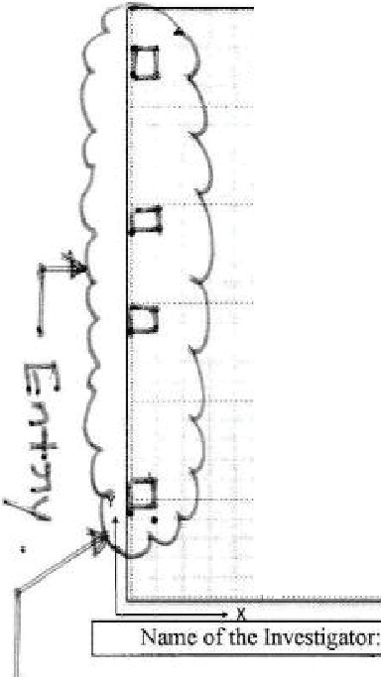


I e1a:no.-J :it':: 8 (rife

A2

- Calculation of Visual Rating index
The Visual Rating index (JvR) is calculated by Eq. (2.1) of Chapter 2.
fvR =-1-[rc(bi J + rinf(tinf .RinfJ + 7cw(tcw.RcwJ]�v-�H.FD.FY
n.w ls ls l,
The notation of each item in equation are as follows:
re= The average shear strength of column = 1.0MPa Tsw=The average shear strength of shear walls = 1.0 MPa Tin_FThe average shear strength masonry infill = 0.20 MPa n= Number of story= 5 (Five)
w=Unit weight of buildings= 11 kNm-²
foz.F Thickness of masonry infill= 125mm
tew= Thickness of concrete wall= No Concrete wall Visual Rating parameters:
be=Average column size= 500 mm ls=Average span length= 5000 mm
RinJ=Masonry infill ratio,= 1/28, 1/24 (Consider the minimum value, 1/28)
Rew=Concrete wall ratio, =0 (Considering minimum direction) The reduction factors are as follows:
FIV=The modification factors for vertical irregularity= 1.0 FIH= The modification factors for horizontal irregularity = 1.0 FD= The modification factors deterioration of concrete= 1.0
Fy = The modification factors for year of construction= 0.95
2

lvR
1000[ 1 ( -50-0 )
+ 0.2 (
-1x2-5 1 )
+ lx0 ] lxlxlx0.95 = 0.185

5x11 50020 5000 28

According to Judgement criteria, the building will be classified into 'C'

A3

Example Building-02

Name of the Building: BG Press Staff Quarter (Quarter Number-Q) Address: Tejgaon, Dhaka.

- Pictorial Preview:

  - 5 Storied Residential Building

- Exterior Wall with Opening in Front of the Building
  - In Frame Interior Wall with
Openings

- One Solid Exterior Wall in the Outside Frame of the Building

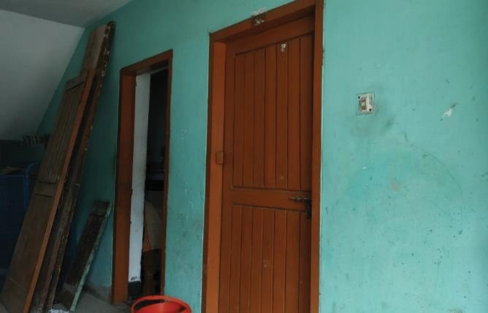
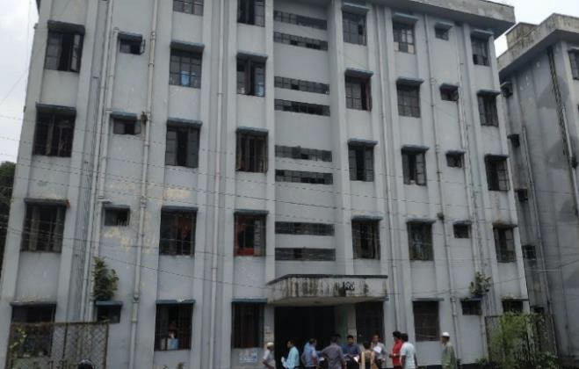
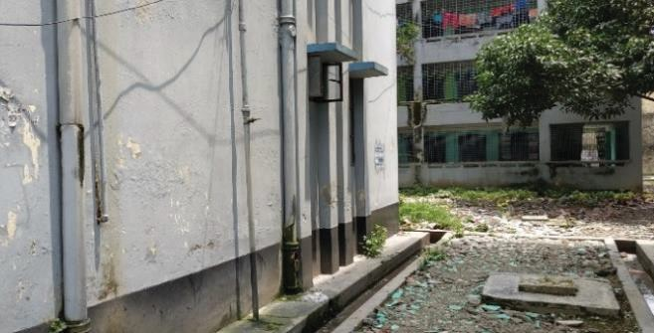
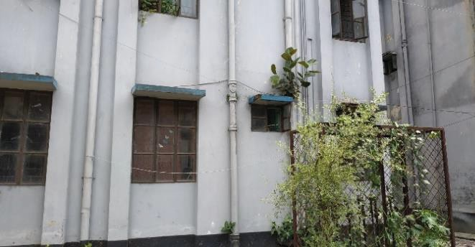

A4

- Completed VR Survey Datasheet:

Visual Rating (VR) Survey Sheet
NameofBuilding: 8G, 'Pr� ,S-1-o,J Q,Wl..n+en (�
"°'
Address: Tej �OJ)Yl I k:::0- •

Date:  2.0 1.:3

Please read carefully the selection criteria and put circle fol in the appropriate items
No | Items | Selection Criteria | Categories |  |  |  |  |  |  |  | Please specify, Jf the value is found | Note
I | No of story (n) | ?ut story number | Re..:S· den-Ho. L. |  |  |  |  |  |  |  | OS
2 | Representative colwnn size (b, ), (mm) | Please exclude the mortar/plaster  thickness 50 mm | �  � | 350 nun -  450 mm | 450 mm- 55  550mm | 0 mm -  650 nun | 650 mm~  750 ,nm | 750nun-  850mm | 850mm-950 mm | 950mm  - larger | 12�01  1<.,30"0  nun
J | Average span  length(/,), (m) | The size of equivalent square floor j  area carried by a single column | 2.50m�  3.50 ";) | 3.50 m-  4.50 m | 4.50 m -  5.50 m | 5,50 Ill -  6.50 m | 6.50111-  7.50m | 7.50m-  8.50 m | 8.50 m -  9 50 Ill | 6 SO m-  larger | CJ  nun
4 | Masonry infill =  ra1io | Masonry infill Ratio, R111,:  No of infill panel in x or yd.tr. | @:]  X-direction  I15"1 |  |  |  |  | 12;;;;,  Y-direcuon  E]
4 | Masonry infill =  ra1io | Total 110 of span in x or y dir.
5 | Concrete walI  ratio | Concrete wall Ratio, R�..,:  = No of Concrete wall in x or y air | X-direction �  11s-1 |  |  |  |  | Y-direction 1aJ  0J-
5 | Concrete walI  ratio | Totat no of span in x or y dir.
6 | Vertical  i1Tegularity, F1v | Regular= No irregularity | Regular  (I) |  |  | early regular  (0.8) |  |  | Irregular  (0,6)  ,.
6 | Vertical  i1Tegularity, F1v | Nearly Regular= Small opening at ground floor
6 | Vertical  i1Tegularity, F1v | Irregular- Ground floor  opening/parking
7 | Horizontal irrcguJariry. F1H | Rcgulnt'" No irregularity | Regular  (I) |  |  | Nearly rcgulnr  (0.8) |  |  | "  Irregular  (0.6)
7 | Horizontal irrcguJariry. F1H | Nearly Regular= Small projection  exists with irregular shape
7 | Horizontal irrcguJariry. F1H | Irregular- large projection with  irregular shape
8 | Deterioration of concrete, F₀ | INone= No deterioration | @) |  |  | Minor  (09) |  |  | Severe::  (0.8)
8 | Deterioration of concrete, F₀ | Minor- Some crack in strucm.ml element
8 | Deterioration of concrete, F₀ | Severe= Spalli.ng of concrete and  major Crack
9 | Year of  construction (fy) | !New= less than 15 years  Middle= 15-30 years | New  {I) |  |  | ®) |  |  | Old (0.9)
9 | Year of  construction (fy) | Old= More than 30 years
•numeral 1n parenthesis1nd1cates corresponding we1gtnage� �
LeQends
- � "1 WALL W/OPENL 'G

Please draw a sketch the RC colwnn with Masonry infill
--- M SOLID INFILL I ALL
=RCWALL

Hlb:-::,
ame of the l.nves1iga1or:

tJa.san

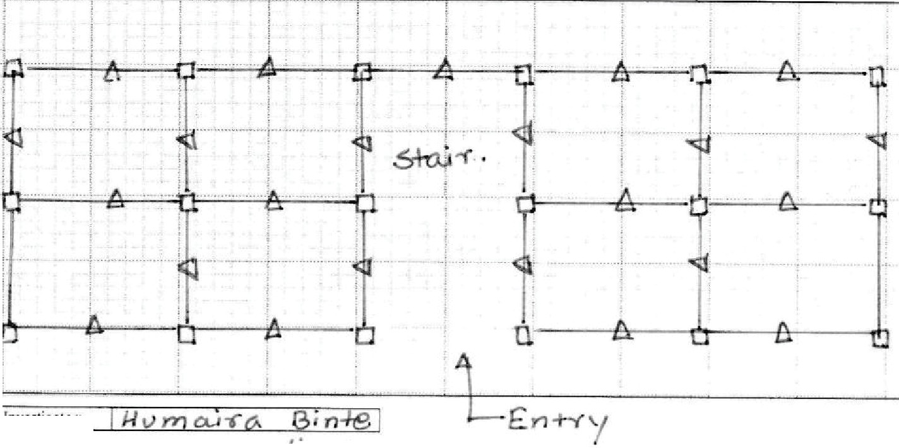

AS

- Calculation of VR Index

The Visual Rating Index (JvR) is calculated by Eq. (2.1) of Chapter 2.
1
JVR= - -[Tc(b; J +Tinf(tinf.RinfJ +Tcw(tcw.RcwJ]FIV"FIH.FD.FY
n.w ls ls ls
The notation of each item in equation are as follows:
re= The average shear strength of column = 1.0MPa
Tew =The average shear strength of shear walls = 1.0 MPa Ti,rthe average shear strength masonry infill = 0.2 Mpa n= Number of story = 5 (Five)
w=Unit weight of buildings= 11 kNm-²
linF Thickness of masonry infill = 125mm
tew= Thickness of concrete wall= No concrete wall Visual Rating Parameters:
be=Average column size= 300mm ls=Average span length= 3000 mm
Rief=Masonry infill ratio,= 0/15, 2/12 (Consider the minimum value, 0/15)
Rew =Concrete wall ratio, = 0 (due to no concrete wall) The reduction factors are as follows:
Fn;=The modification factors for vertical irregularity= 1.0 FIH= The modification factors for horizontal irregularity = 1.0 FD = The modification factors deterioration of concrete = 1.0 Fr= The modification factors for year of construction= 0.95
lv_R_1_000 [ 1( -3-00 2) + 0.2 ( -1x205 ) + lx0 ] lxlxlx0.95 = 0.172
Sxll 30002 3000

According to Judgement criteria, the building will be classified as a 'C'

A6

Joint Coordination Committee

Chairperson
Jamilur Reza Choudhury Md. Jahangir Alam

University of Asia Pacific (- April 2020) University of Science and Technology Chittagong (December 2021- June 2022)

Working Groups of SATREPS-TSUIB project

Working Group 1 (WGl): Data collection on building stock in Dhaka

Co-Leader Co-Leader
Yoshiaki Nakano Md. Ashraful Alam
The University of Tokyo
Housing and Building Research Institute

Working Group 2 (WG2): Development of seismic performance evaluation methodologies

Co-Leader Co-Leader
Masaki Maeda Md. Rafiqul Islam
Tohoku University
Public Works Department

Working Group 3 (WG3): Development of seismic retrofit schemes

Co-Leader Co-Leader
Yasushi Sanada Osaka University
A.F.M. Saiful Amin Bangladesh University of Engineering and Technology

Working Group 4 (WG4): Development of efficient and effective urban planning strategies

Co-Leader Co-Leader
Michio Ubaura Tohoku University
Md. Akter Mahmud Jahangimagar University

A7

Working Group 2 (WG2)

Co-Leader Co-Leader
Masaki Maeda Md. Rafiqul Islam
Tohoku University
Public Works Department

Members (Not in order of seniority)
Yoshiaki Nakano Md. Ashraful Alam Yasushi Sanada
Md. Abdul Malek Sikder Iftekhar Anam
A.F.M. Saiful Amin Matsutaro Seki Tomoya Nishiwaki Kazuto Matsukawa Susumu Takahashi
Md. Abdur Rahman Bhuiyan Md. Mizanur Rahman Sharmin Reza Chowdhury Hamood Alwahshali
Md. Shafiul Islam Fatema-Tuz-Zahura Debasish Sen
Md. Jahidul Islam Khan Humaira Binte Hasan Md. Raquibul Hasan Md. Iftekharul Islam Md. Arifujjaman
Md. Ibnul Warah Fumio Kaneko Joji Sakuta Tsutomu Ohta Yuji Haga
S.A.M Nassif Zubayer Anik Das
S. M. Muhaiminul Islam Farzana Khanam Munirul Islam Saeed Sristi Das Gupta

The University of Tokyo
Housing and Building Research Institute Osaka University
Housing and Building Research Institute University of Asia Pacific
Bangladesh University of Engineering and Technology Building Research Institute
Tohoku University
The University of Tokyo Daido University
Housing and Building Research Institute
Bangladesh University of Engineering and Technology Ahsanullah University of Science and Technology Tohoku University
Housing and Building Research Institute
Ahsanullah University of Science and Technology Ahsanullah University of Science and Technology Public Works Department
Public Works Department Public Works Department Public Works Department
Housing and Building Research Institute Housing and Building Research Institute OYO Corporation
Rorie Engineering and Architectural Research Institute Co., Ltd Rorie Engineering and Architectural Research Institute Co., Ltd The University of Tokyo
Public Works Department
Housing and Building Research Institute Housing and Building Research Institute Housing and Building Research Institute
Ahsanullah University of Science and Technology Ahsanullah University of Science and Technology
A8

Prepared Under
SATREPS-TSUIB Project
A Japan-Bangladesh Joint Research Project







BUET    PWD

